CHAPTER 2 – THEORETICAL AND SCIENTIFIC FOUNDATIONS
2.1 Powder Mechanics and Flow Behavior
The study of bulk solids mechanics represents the scientific and engineering foundation for designing both volumetric and gravimetric filling systems, particularly auger filling systems. Powders behave fundamentally differently from both continuous solids and Newtonian fluids; they do not follow classical hydrodynamic laws, cannot sustain tensile stresses, and their mechanical behavior depends on a complex interaction of frictional forces, cohesion, compaction, and inter-particle contact forces [3].
Bulk solids and powders differ radically from conventional fluid mechanics and continuum solid mechanics. While fluids cannot sustain shear stress at rest, powders exhibit a yield strength and the ability to transmit stresses through force chains between particles. In the context of designing an auger filling system for salt (NaCl), powder behavior directly influences the required torque, volumetric dosing accuracy, and flow stability. Therefore, characterizing the physical and mechanical properties of the material—specifically sodium chloride (NaCl)—is essential.
This section establishes the physical principles governing material behavior and their direct impact on system design decisions. It represents the fundamental step toward developing a valid analytical model and verifying it using numerical simulation (DEM) [4].

2.1.1 Physicochemical Properties of the Target Material (NaCl)
The target material in this project is sodium chloride (table salt). From an engineering perspective, bulk solids behave as a system of discrete particles that interact through friction and mechanical contact. Based on approved safety data and standard specifications [1], salt exhibits the following fundamental properties that directly influence mechanical design decisions:
- Crystalline Structure:
Salt has a cubic crystalline structure (crystalline powder), which gives the particles relative hardness and sharp edges. From an engineering standpoint, this structure increases the internal friction coefficient between particles and also introduces challenges related to surface abrasiveness on contacting metallic components over time. This was considered in the selection of stainless steel (SS304/316L) for moving parts due to its corrosion resistance and food compatibility [1].
- Density Properties:
It is essential to clearly distinguish between two types of density when performing design calculations:

- True Density ($ρ_{ρ}$):
The density of the solid material itself without voids, approximately $2165–2170 kg/m³ (≈ 2.165 g/cm³)$for pure salt [1].

- Bulk Density ($ρ_{b}$):
The operational density including inter-particle air voids, and the critical parameter for calculating hopper volume and auger capacity. For dry granular salt, it typically ranges between 1100 and 1300 kg/m³, most commonly 1200 and 1300 kg/m³ after exposure to vibration or consolidation pressure caused by the material column inside the hopper [1][2].
This variation depends on the filling method and particle size distribution (PSD). Any fluctuation in bulk density due to consolidation directly causes variation in the final package weight, therefore maintaining a constant material level in the hopper is necessary to ensure constant head pressure.

Bulk density is defined as the mass of powder per unit bulk volume, including void spaces [14].
$$m=ρ_{bulk}*V$$
Where m is the mass delivered, $ρ_{bulk}$ is the bulk density, and V is the volumetric displacement
Two density states are typically considered [14]:
- Loose bulk density
- Tapped (consolidated) bulk density
Consolidation increases normal stress within the powder column, altering shear resistance and torque demand [15]. Variations in bulk density directly affect dosing accuracy in volumetric auger systems [16].

Bulk density is defined as the mass of powder divided by its total bulk volume, including inter-particle voids. It is the key parameter that converts the volumetric displacement of the auger into gravimetric mass flow:
$$m˙=Vrev​⋅N⋅ρ_{b}​⋅η_{v}​$$
Where $\dot{m }\frac{kg}{min}$ is the mass flow rate, $V_{rev}$ is the swept volume per revolution, $N$ is the rotational speed, and ${ η}_{v}$is the volumetric efficiency[9][4].

However, bulk density is not constant; it increases with consolidation pressure (head pressure in the hopper) and vibration, a phenomenon known as compressibility.
- Hygroscopicity and Moisture Effect:
Salt is a hygroscopic material, meaning it absorbs moisture from the surrounding environment. At high relative humidity, liquid bridges form between particles, which may later dry into solid salt bridges. This changes the material state from free-flowing to cohesive (caking). This issue was addressed in the design by incorporating a mechanical agitator inside the hopper that continuously breaks these bridges and maintains material flowability [1].

Density Variation During Operation:
Bulk density may vary during operation due to vibration, humidity changes, particle size distribution, and consolidation under the weight of the material column. These variations directly affect dosing accuracy and must therefore be considered in modeling and numerical validation.

2.1.2 Nature of Bulk Solids
Bulk solids behave as discrete particulate systems rather than continuous media [8]. Their macroscopic response emerges from microscopic interactions between individual particles [9].

Key characteristics of bulk solids include a Stress transmission through force chains [10], Absence of tensile strength under low confinement [11], Pressure-dependent shear resistance [12], and Density variation under consolidation [13]

Unlike fluids, bulk solids can form stable free surfaces at an angle known as the angle of repose [12], which is directly related to internal friction.
In contrast to fluids, which cannot sustain shear stress at rest, bulk solids possess a yield strength. This means that a powder can withstand shear stress without flowing until a certain critical value is exceeded. The stress state within bulk solids is commonly described using Mohr’s Circles and the Yield Locus, where the shear stress required to initiate flow (τ) depends on the applied normal stress (σ) according to the Coulomb friction law:
$$τ=σ*\tan\left(∅\right)+c$$
Where (∅) represents the angle of internal friction, and (c) the cohesion forces. For free-flowing materials, the cohesion value is close to zero, while it increases in cohesive materials such as wet salt [5].

This distinction is critical when modeling auger filling, since powder does not flow automatically when a container is opened; instead, it requires shear-induced motion generated by the rotating screw.

2.1.3 Forces Acting on Particles
Particles within bulk solids are subjected to a complex system of interacting forces that govern whether the material flows or remains stagnant. From a dynamic standpoint, the stability or motion of the material inside the hopper and auger depends on the resultant balance between two primary categories of forces [4].

First: Driving Forces
These are the forces that promote particle motion and overcome frictional resistance, including:

- Gravitational Force ($F_{g}$): The dominant force responsible for gravity-driven discharge from the hopper.

- External Mechanical Forces ($F_{ext}$): Generated by the pressure of the screw flights or the motion of the agitator blades, which forcibly mobilize the material through externally applied mechanical loading.

Second: Resisting Forces
These forces oppose motion and contribute to torque demand, including:

- Frictional and Contact Forces: Arising from mechanical interlocking between irregular particle surfaces, or between particles and machine walls.
- Cohesive Forces: Originating from van der Waals interactions and electrostatic attraction.
- Liquid and Solid Bridges: Particularly significant in hygroscopic materials such as salt. Absorbed moisture forms liquid bridges between crystals, which may solidify upon drying into salt bridges, substantially increasing shear resistance and hindering flow [2].

Mathematical Model of Failure (Mohr–Coulomb Failure Criterion)
To analyze the onset of material flow (i.e., structural failure of the powder and initiation of motion), the Mohr–Coulomb shear failure criterion is applied:
$$τ=σ*\tan\left(∅\right)+c$$
Where ($τ$) represents the shear stress required to initiate flow, ($∅$) the angle of internal friction, ($c$) the cohesion forces, and ($σ$) the normal stress applied to the material. For free-flowing materials, the cohesion value is close to zero, while it increases in cohesive materials such as wet salt [3].
In dry salt (free-flowing),
$c≈0$, meaning flow resistance is governed primarily by internal friction. However, in moist salt, cohesion increases, requiring higher shear stress (and consequently greater motor torque) to overcome flow resistance [3].
The internal friction angle (𝜙) is directly related to the angle of repose, which for salt typically ranges between $30°$ and $45°$ [6]. From an engineering perspective, a larger angle indicates greater resistance to sliding, necessitating hopper wall angles steeper than the angle of repose to ensure gravity flow, or alternatively, higher motor torque to overcome shear resistance within the filling chamber.

2.1.4 Wall Friction and Boundary Interaction
In addition to internal friction between particles, powder in motion is subjected to mechanical interaction with surrounding solid boundaries, particularly hopper walls and the auger casing. This interaction is known as wall friction and can be mathematically described using the Coulomb friction model as follows [5][3]:
$$τ_{w}=σ_{w}*μ_{w}=σ_{w}*tan⁡(∅_{w})$$
Where $τ_{w}$is the shear stress at the wall, $σ_{w}$_w is the normal stress acting on the wall (Wall Normal Stress), $μ_{w}$ is the wall friction coefficient, and $∅_{w}$ is the wall friction angle.

Effect of Wall Friction on Machine Performance
The magnitude of the wall friction coefficient ($μ_{w}$) directly influences the efficiency of the filling system. Higher wall friction results in:
- Increased Torque Requirement: A significant portion of motor power is consumed in overcoming shear resistance along the casing wall.
- Risk of Material Buildup: Elevated friction promotes adhesion of fine particles to surfaces, gradually reducing the effective internal diameter of the tube.
- Flow Inconsistency: High friction may induce stick–slip behavior, negatively affecting dosing accuracy and mass consistency.

Design Considerations and Material Selection
Experimental studies on crystalline powders such as salt and sugar interacting with metallic surfaces indicate that the wall friction angle ($∅_{w}$) typically ranges between $15°$ and $25°$ when stainless steel with a (2B Finish)surface finish is used [5].
To enhance flowability and minimize energy consumption, the proposed design adopts polished stainless steel (SS304L) for all product-contact components. This ensures a low wall friction coefficient ($μ_{w}<0.3$) while also providing resistance against chemical and mechanical wear.

2.1.5 Angle of Repose and Flowability
The angle of repose is defined as the maximum angle at which a powder can remain stable without collapsing. It serves as a direct indicator of material flowability and internal friction characteristics.
Flowability Classification:
- Free-flowing:( $∅< {30}^{°}$)
- Moderate flow: (${30}^{°}$) – (${45}^{°}$)
- Cohesive: (${45}^{°}$)

For dry granular salt, the typical angle of repose ranges between $30°$ and $35°$ [3], indicating relatively good flowability. However, the presence of moisture increases inter-particle cohesion due to the formation of liquid bridges, which significantly reduces flowability and promotes agglomeration [16][17].

2.1.6 Flow Patterns in Hoppers
The precise performance of an auger filling system depends fundamentally on the stability of material flow from the hopper to the screw zone. According to Jenike and Schulze theories in bulk solids mechanics [3][6], powders typically exhibit one of two primary flow patterns during hopper discharge:
1. Mass Flow
In this regime, the entire bulk of material inside the hopper—including the layers adjacent to the walls—moves uniformly during discharge. This is considered the ideal condition for food powders such as salt because it ensures the First-In, First-Out (FIFO) principle, preventing material stagnation and maintaining uniform bulk density at the auger inlet [19].
2. Funnel Flow
This occurs when material flows only through a central channel directly above the outlet, while peripheral regions remain stagnant and compacted (stagnant zones). Funnel flow is undesirable in precision dosing applications because it can lead to serious operational issues, including:
- Ratholing: Formation of a vertical void above the screw that prevents material from descending.
- Bridging: Development of a stable arch over the outlet that completely blocks flow.
- Torque Oscillation: Caused by sudden variations in bulk density, reducing final weight accuracy [17].

Effect of Angle of Repose
To predict the expected flow pattern and properly design the hopper, the angle of repose ($∅$) must be evaluated. It represents the maximum slope angle at which a material can remain stable without collapsing and is directly related to internal friction and cohesion. For most salt types, the angle of repose typically ranges between $30°$ and $45°$[19][20].

Design Decision
To ensure mass flow and eliminate funnel-flow problems such as bridging and ratholing, the following design criteria were implemented in the VFFS hopper:
- Steep Hopper Angle: Hopper walls were designed with an inclination angle of ($∅≥{60}^{°}$)
relative to the horizontal—greater than both the angle of repose and wall friction angle of salt—forcing full material sliding and preventing stagnation [4][18].

- Agitation System: To overcome bridging, ratholing, and segregation, an independent mechanical agitator/stirrer was integrated into the hopper design. Operating in parallel with the auger, it performs the following functions:
- Bridge Breaking: Continuously destroys cohesive arches forming above the screw.
- Homogenization: Re-mixes fine and coarse particles to minimize segregation and stabilize bulk density.
- Force Feeding: Actively pushes powder toward the auger flights to ensure full screw filling in each revolution, thereby improving dosing accuracy.

2.1.7 Flow Obstructions and Powder Instability
Flow obstructions and non-uniform particle distribution are among the most critical challenges facing auger filling systems. These phenomena lead to variations in product bulk density, sharp fluctuations in the torque required by the drive motor, and ultimately inaccuracies in the final package weight. The following provides a detailed description of these phenomena and their mechanisms:
First: Arching / Bridging
Arching is the formation of a stable arch of material above the auger feed opening, resulting in a complete stoppage of product flow despite continued auger rotation. Arching is classified into two main types based on the underlying physical mechanism [3]:

- Mechanical Arching: Occurs when irregularly shaped or large particles mechanically interlock at the outlet, forming a self-supporting structure that resists collapse.
- Cohesive Arching: The most common type in fine or moist powders (such as salt), where interparticle cohesive forces and wall friction exceed the of the column, preventing it from collapsing toward the auger.
Second: Tubular gaps (Ratholing)
This phenomenon commonly occurs in hoppers operating under funnel flow conditions. Only the material directly above the auger outlet discharges, while the surrounding material remains stagnant and consolidated along the hopper walls. This results in intermittent flow, and when the stagnant zones suddenly collapse (sloughing), an uncontrolled surge of (flooding) may occur, overwhelming the auger and causing significant weighing errors [4].
Third: Caking (clumping and hardening)
Since sodium chloride (NaCl) is a hygroscopic material, it tends to absorb moisture from the surrounding environment, leading to a sequence of physical transformations [1]:
- Formation of liquid bridges at particle Contact points due to moisture condensation.
- Upon temperature reduction or partial drying, dissolved salts crystallize, transforming liquid bridges into solid bridges with high mechanical strength.
- As a result, the powder transitions from a free-flowing state to hard agglomerates that may mechanically block the auger or even damage the agitator blades.
Fourth: Segregation
Segregation is a demixing mechanism in which particles separate due to differences in size or density [4].

- Sifting / Percolation Mechanism: Fine particles migrate downward through voids between coarse particles and accumulate at the bottom, while larger particles remain at the top or roll toward the hopper sides.
- Impact on Filling Accuracy: Segregation causes continuous variation in the bulk density encountered by the auger during operation, leading to volumetric dosing inaccuracies, since the auger delivers a constant volume but with a variable mass.

2.1.8 Flowability Classification
Flowability is not an intrinsic material property such as density or moisture content; rather, it is the result of a complex interaction between the physical characteristics of the powder and the equipment used to handle it. For the engineering design of an auger filling machine, two primary criteria are adopted to classify the flow behavior of salt: the Flow Function (${ff}_{c})$derived from shear testing, and the Hausner Ratio ($HR$) derived from density measurements.

First: Flow Function (${ff}_{c}$)
This criterion is considered the most accurate for hopper design and for determining wall angles required to ensure reliable flow. According to Jenike’s theory and Schulze’s developments [3], the flow function is defined as the ratio between the major consolidation stress ($σ_{1}$) and the unconfined yield strength ($σ_{c}$):
$${ff}_{c}=\frac{σ_{1}}{σ_{c}}$$
Where ${ σ}_{1}$ is a (Consolidation Stress): The stress applied to the powder during storage that causes compaction and ${ σ}_{c}$ is (Unconfined Yield Strength): The stress required to break a formed arch or bridge and initiate flow.

Higher (${ff}_{c}$)values indicate easier material flow. Table (2-1) presents the standard engineering classification:

Table 2-1: Flowability Classification based on Flow Function (${ff}_{c}$) [1].
Design Implication | Flow Function (${ff}_{c}$​) | Flowability Description
No arching problems; standard hopper angles are sufficient | $${ff}_{c} >10$$ | Free-flowing
Requires properly designed hopper angles to avoid funnel flow | $$4 <{ff}_{c}<10$$ | Easy-flowing
Requires larger outlet size and use of an agitator | $$2 <{ff}_{c} < 4$$ | Cohesive
Requires flow-aid systems (vibration or aeration) | $$1 <{ff}_{c} < 2$$ | Very Cohesive
Behaves as a solid mass (e.g., severely caked salt) | $${ff}_{c}<1$$ | Non-flowing

Second: Hausner Ratio (HR)
This index provides a rapid estimation of flowability based on powder compressibility. It is calculated as the ratio of tapped density to bulk density:
$$HR=\frac{ρ_{tapped}}{ρ_{bulk}}$$
For sodium chloride (NaCl) powder, reference data indicate that its behavior varies with moisture content. Dry salt typically has $HR ≈1.15$(easy-flowing), but when moisture is absorbed, the ratio increases and the material enters the cohesive range [6].

Table 2-2: Flowability Classification based on Hausner Ratio [4].
Carr Index (CI %) | Hausner Ratio (HR) | Flow Character
$$≤10$$ | $$1.00 - 1.11$$ | Excellent
$$11 - 15$$ | $$1.12 - 1.18$$ | Good
$$16 - 20$$ | $$1.19 - 1.25$$ | Fair
$$21 - 25$$ | $$1.26 - 1.34$$ | Passable
$$26 - 31$$ | $$1.35 - 1.45$$ | Poor (Cohesive)
$$> 32$$ | $$> 1.46$$ | Very Poor

Design Conclusion
Based on the above classifications, salt in this project is treated as an easy-flowing material under ideal conditions (${ff}_{c}>4$). However, the mechanical design must account for the worst-case scenario, in which the material may become cohesive (${ff}_{c}≈3)$ due to increased moisture or prolonged storage.

Accordingly, the following design decisions were adopted:
- Incorporation of an agitator system to break agglomerates and reduce apparent cohesion.
- Designing hopper wall angles and auger flight geometry to handle materials with moderate internal friction, ensuring sufficient torque under all operating conditions.

Actual References Corresponding to [1]–[23] (Reformatted)
[1] Sigma-Aldrich. (2018). Sodium Chloride Product Specification & Data Sheet (Nos. 71376, 71386). Merck KGaA.
[2] Brinckmann, S., et al. (2009). A combined experimental-numerical study of the compaction behavior of NaCl. Powder Technology, 194, 197–206.
[3] Wassgren, C. (2024). Introduction to Powder Storage and Flow. Course Notes, School of Mechanical Engineering, Purdue University.
[4] Schulze, D. (2007). Powders and Bulk Solids: Behavior, Characterization, Storage and Flow. Springer Berlin Heidelberg.
[5] Hancock, B. C. (2019). The wall friction properties of pharmaceutical powders, blends, and granulations. Journal of Pharmaceutical Sciences, 108(2), 812–820.
[6] ASTM D6128. Standard Test Method for Shear Testing of Bulk Solids Using the Jenike Shear Cell. ASTM International.
[7] Cargill. (n.d.). Bulk Deicing Salt FAQs.
https://www.cargill.com/industrial/winter-road-maintenance/bulk-deicing-salt-faqs
[8] Jenike, A. W. (1964). Storage and Flow of Solids. Bulletin No. 123, Utah Engineering Experiment Station, University of Utah.
[9] Thornton, C. (2015). Granular Dynamics, Contact Mechanics and Particle System Simulations. Springer.
[10] Jenike, A. W., & Johanson, R. T. (1968). Bin loads – Part 2: Concepts for bins and hoppers. Journal of Engineering for Industry, ASME.
[11] Duran, J. (2000). Sands, Powders, and Grains: An Introduction to the Physics of Granular Materials. Springer-Verlag, New York.
[12 14] Nedderman, R. M. (1992). Statics and Kinematics of Granular Materials. Cambridge University Press.
[13] Schulze, D. (2008). Powders and Bulk Solids: Behavior, Characterization, Storage and Flow. Springer.
[14] Carr, R. L. (1965). Evaluating flow properties of solids. Chemical Engineering, 72, 163–168.
[15 18] Schwedes, J. (2003). Review on testers for measuring flow properties of bulk solids. Granular Matter, 5, 1–43.
[16 19] Woodcock, C. R., & Mason, J. S. (1987). Bulk Solids Handling: An Introduction to the Practice and Technology. Blackie Academic & Professional.
[17 20] University of Utah. (n.d.). The Geometry of Piles of Salt.
https://www.math.utah.edu/mathed/teachersmathcircle/Geometry%20of%20Piles%20of%20Salt.pdf
[18 21] Śmiechowska, M., Ruszkowska, M., & Wawrzyniak, J. (2021). Selected quality characteristics of sea salt important during transport and storage. Acta Scientiarum Polonorum Technologia Alimentaria, 20(3), 323–332.
[19 23] Levapack. (2024). Comprehensive Guide to Powder Filling Machine.
https://www.levapack.com/powder-filling-machine-guide/
[20 22] Engineering Toolbox. (n.d.). Angles of Repose.
https://www.engineeringtoolbox.com/dumping-angles-d_1531.html

2.2 Auger Filling Theory and Mechanisms
The principles governing auger filling systems are deeply rooted in the historical development of screw conveying mechanisms and the fundamental kinematics of helical motion. This section delineates the theoretical underpinnings, mathematical derivations, and scientific models that describe the volumetric displacement, mass flow dynamics, and efficiency considerations inherent in auger filling operations.This section also provides a rigorous academic treatment of these foundational aspects, essential for understanding the design and operation of modern auger fillers.

2.2.1 Historical and Scientific Foundation of Screw Conveying
2.2.1.1 Historical Genesis and Evolution
The conceptual foundation of screw conveying traces its origins to the Hellenistic period, specifically to the 3rd century BCE, with the invention traditionally attributed to Archimedes of Syracuse (287–212 BCE). The original Archimedean screw (or cochlea) was engineered as a hydraulic device for lifting water from lower elevations to irrigation channels, and for dewatering mines and ship bilges [1]. This early mechanism comprised a helical surface (flight) wound around a central cylindrical shaft, enclosed within a tight-fitting cylindrical casing. The fundamental operating principle involved the conversion of continuous rotational motion into controlled axial displacement a kinematic transformation that would prove remarkably versatile across millennia [1, 2].
For nearly two millennia, the application of the Archimedean screw remained largely confined to fluid transport. However, the advent of the Industrial Revolution in the 18th and 19th centuries precipitated a paradigm shift in material handling requirements. The geometric elegance of the helical mechanism demonstrated its equal applicability to granular and particulate solids, transcending its original fluidic domain [3, 4]. Early industrial implementations emerged in agricultural milling for grain handling, subsequently expanding to mining operations for coal and mineral transport, and to power generation facilities for ash management [3, 5].
The 19th and 20th centuries witnessed substantial engineering refinements, including the standardization of geometric proportions, advancements in helical flight manufacturing techniques, and the integration of electric drive systems for automated operation [2, 6]. By the mid-20th century, industrial standards most notably those promulgated by the Conveyor Equipment Manufacturers Association (CEMA) formalized design methodologies, establishing empirical capacity equations, geometric correction factors, and operational safety protocols [2]. These developments transformed the rudimentary Archimedean principle into the sophisticated screw conveyor systems ubiquitous in contemporary bulk solids handling industries, including agriculture, pharmaceuticals, chemicals, and food processing [2, 3].
2.2.1.2 Scientific Distinction: Fluid Mechanics versus Bulk Solids Mechanics
A critical scientific distinction must be established between hydraulic pumping systems and screw conveying mechanisms. While both technologies utilize rotational motion to induce material displacement, their underlying physics diverge fundamentally [3, 4].
Fluid pumping operates within the domain of continuum mechanics, where material behavior is governed by the Navier–Stokes equations and characterized by viscosity, pressure gradients, and incompressible flow assumptions. In contrast, screw conveyors function within the mechanics of bulk solids—a discrete, multiphase system where material behavior is dictated by interparticle friction, cohesive forces, granular shear resistance, and internal yield stress [3, 4]. Bulk solids exhibit distinct mechanical properties including angle of repose, flowability indices, and potential cohesive arching, rendering classical fluid dynamic models entirely inapplicable [3, 4]. Consequently, the analysis and design of screw conveying systems necessitate the application of granular mechanics, powder rheology, and bulk solids flow theory, as systematically developed by Jenike [3] and Nedderman [4].
2.2.1.3 The Transition to Precision Metering: Emergence of Auger Filling Technology
The latter half of the 20th century marked a significant functional evolution: the transition from bulk material transport to precision volumetric metering. In packaging, pharmaceutical, and food processing industries, the screw mechanism was adapted to perform controlled dosing, wherein discrete angular displacement of the screw produces repeatable, quantifiable material discharge [5, 6]. This functional transformation reclassified the device from a continuous conveyor to a positive-displacement metering mechanism termed the auger filler or auger dosing system.
This adaptation represents more than a mere scale reduction; it constitutes a specialized engineering domain integrating:
- Helical geometry and rigid-body kinematics: governing the relationship between rotational input and axial material displacement;
- Granular mechanics and shear flow theory: characterizing particle motion within the screw channel;
- Frictictional contact mechanics: determining particle-boundary interactions and torque requirements;
- Volumetric metering principles: ensuring repeatability and accuracy in discrete dosing [3, 4, 5].
Modern auger filling systems embody the convergence of these mechanical principles with advanced control technologies, including servo-electric drives and digital control architectures (e.g., ESP32 microcontrollers), enabling gravimetric precision to fractional-gram resolutions [6]. This technological synthesis renders auger filling particularly suitable for challenging particulate materials—such as hygroscopic salts, fine powders, and cohesive granular substances where conventional volumetric methods prove inadequate.
2.2.1.4 Conceptual Framework for Auger Filling Systems
In the context of the present investigation, the auger filler represents the contemporary apotheosis of Archimedean mechanical principles. Unlike its ancestral water-lifting device or its industrial conveying predecessors, the modern auger filler is optimized for volumetric efficiency, flow stability, and dosing repeatability rather than maximum transport capacity. The design emphasis shifts from continuous bulk movement to the precise division of material into discrete, controlled doses a functional distinction that fundamentally differentiates the screw feeder from the screw conveyor [5, 6].
Thus, auger filling theory transcends simple extension of screw conveying principles; it constitutes a specialized interdisciplinary domain requiring systematic integration of mechanical engineering design with bulk material science, control systems engineering, and granular physics.

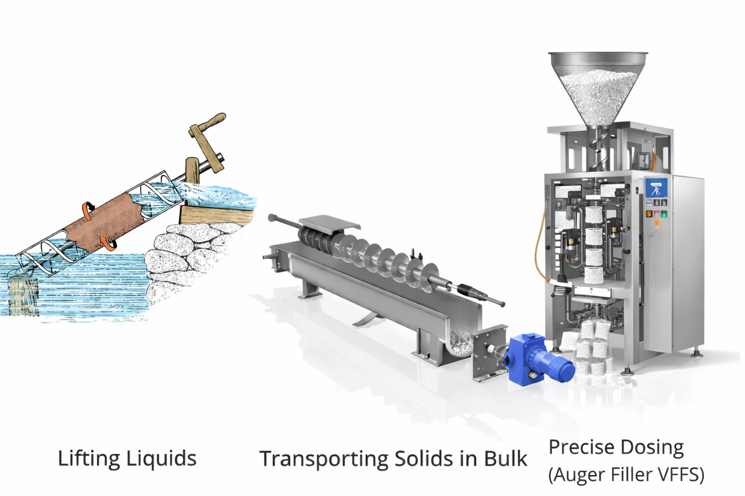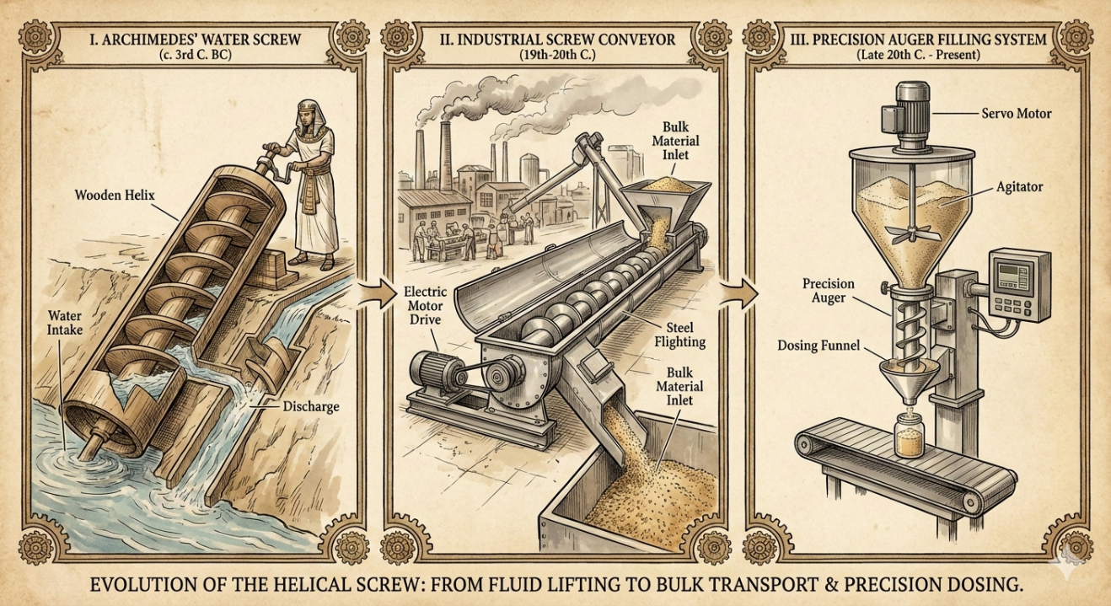
Figure 2.2.1: The figure illustrates the evolution of the transport process from lifting liquids to transporting bulk solids, all the way to precise dosing.

References
[1] Drachmann, A.G. (1963). The Mechanical Technology of Greek and Roman Antiquity. University of Wisconsin Press.
[2] Conveyor Equipment Manufacturers Association (CEMA). Screw Conveyor Engineering Guide. CEMA, Naples, FL.
[3] Jenike, A.W. (1964). Storage and Flow of Solids, Bulletin No. 123. University of Utah Engineering Experiment Station.
[4] Nedderman, R.M. (1992). Statics and Kinematics of Granular Materials. Cambridge University Press.
[5] Bates, L. (2008). "Screw conveyors." In Bulk Solids Handling: Equipment Selection and Operations, pp. 209-232. Wiley-Blackwell.
[6] ISC Manufacturing (2025). "The History of the Screw Conveyor." Available at: https://iscmfg.com/the-history-of-the-screw-conveyor/

2.2.2 Kinematic Principle of Helical Transport
2.2.2.1 Geometric Foundation of Helical Motion
The fundamental kinematic operation of an auger is governed by helical motion—a spatial curve generated by a point rotating around a cylinder at constant angular velocity while simultaneously advancing linearly along the axis. This motion transforms rotational input into controlled axial displacement through the geometric constraint of the screw pitch [2].

For a screw with pitch $P$, one complete revolution ($2\pi$ radians) corresponds to an axial advance equal to the pitch:
$$P=Δx$$
where $Δx$ represents the axial displacement per revolution (m) and $P$denotes the screw pitch $(m/rev)$. This fundamental relationship establishes the geometric basis for all subsequent kinematic analysis.

The rotational kinematics may be expressed in terms of angular velocity $ω$(rad/s) or rotational speed$N (rev/s)$, related through:
$$N=\frac{ω}{2π}​$$
The theoretical axial velocity of material transport, derived from rigid-body kinematics, becomes:
$$v_{ideal}​=N⋅P=\frac{ω}{2π}​⋅P$$
where $v_{ideal}$represents the ideal axial velocity (m/s). This expression constitutes a purely geometric relationship that assumes perfect transmission of motion from screw flight to bulk material [2].

2.2.2.2 Helix Geometry and Velocity Decomposition
The helix angle $α$, measured at the outer diameter $D$, fundamentally determines the directional decomposition of motion into transport and shear components:
$$tan(α)=\frac{P}{π*(D-D_{s})}​$$
This geometric parameter governs the partitioning of motion into:
- Axial velocity component ($v_{z}$): responsible for bulk transport
- Tangential velocity component ($v_{t}$): responsible for shear generation and particle rearrangement

The velocity components for a point at radial distance $r$from the axis are:
$$v_{z}=\frac{P}{2π}*ω=P*N$$
$$v_{t}=r*ω$$
The resultant velocity magnitude follows from vector composition:
$$v_{res}=√{v_{z}}^{2}​+v_{t}^{2}​​={√(P⋅N)}^{2}+{(r⋅ω)}^{2}$$
The helix angle exerts profound influence on system behavior. As $α$increases, axial transport potential increases while radial compression effects decrease. Conversely, as $α$decreases, material compaction and shear intensify, potentially reducing axial transport efficiency [2]. This geometric relationship directly influences torque requirements, power consumption, and volumetric performance.

2.2.2.3 Ideal Transport Model and Real-World Deviations
The kinematic equations presented above are valid under the theoretical assumptions of the ideal transport model:
1. Complete filling of the screw channel
2. No relative slip between material and screw flight
3. Absence of radial leakage or backflow
4. Material behavior as a rigid plug without internal deformation

In real bulk solids systems, these assumptions are rarely satisfied. Granular materials exhibit complex mechanical behavior governed by interparticle friction and cohesion. Slip occurs at interfaces when shear stress exceeds the frictional resistance defined by the Mohr Coulomb yield criterion [3][4].

The actual material velocity $v_{m}​$ is reduced relative to the ideal velocity through a kinematic efficiency factor $η_{k}$
$$v_{m}​=η_{k}​⋅v_{ideal}​$$
where accounts for slip at screw-flight and casing-wall interfaces, as well as internal shear deformation within the granular bulk [3][4].

2.2.4 Transition to Precision Metering: Kinematic Control of Volumetric Displacement
The kinematic relationship between angular displacement and axial advance forms the theoretical foundation for volumetric dosing systems. For a controlled angular displacement $\theta$ (radians), the corresponding theoretical axial displacement becomes:
$$x=\frac{P}{2π}​⋅θ$$
This fundamental equation establishes that the auger converts controlled angular motion into precisely quantifiable volumetric displacement. In precision metering applications, discrete angular positioning of the screw produces repeatable, quantifiable material discharge [2][5].

Modern auger filling systems exploit this kinematic principle through advanced control architectures. Servo-electric drives enable precise angular positioning with resolutions sufficient for fractional-gram dosing accuracy. The integration of this kinematic model with cross-sectional geometry yields the theoretical framework for volumetric capacity calculations, which shall be addressed in subsequent sections.

Thus, the kinematic principle of helical transport transcends simple material conveying; it constitutes the foundational mechanism for precision volumetric metering, wherein geometrically defined rotational motion is transformed into quantifiable axial displacement with repeatability suitable for industrial dosing applications.

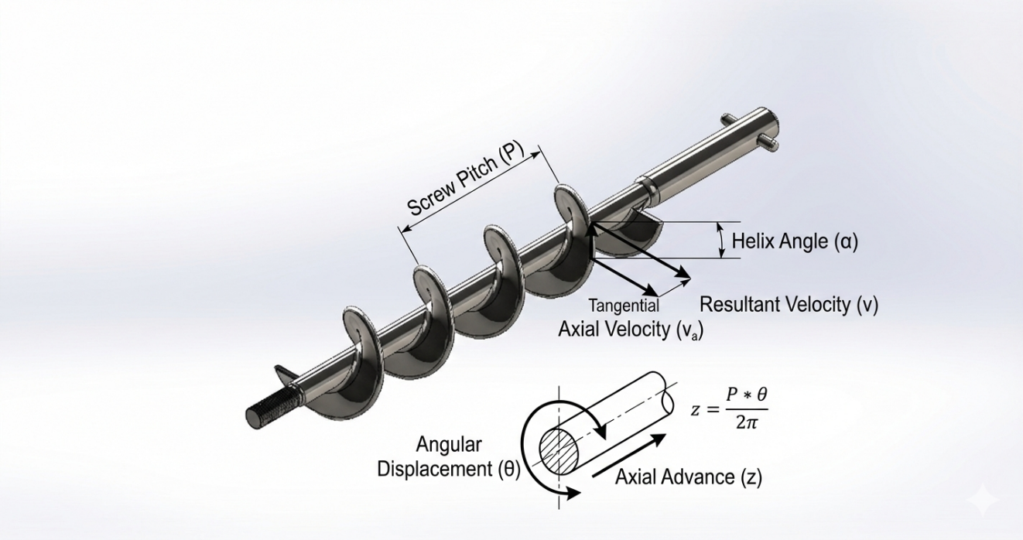
Figure 2.2.2: The figure illustrates the geometric parameters of helical motion, including screw pitch, helical angle, and the relationship between angular displacement and axial advance.

References
[2] Conveyor Equipment Manufacturers Association (CEMA). Screw Conveyor Engineering Guide. CEMA, Naples, FL.
[3] Jenike, A.W. (1964). Storage and Flow of Solids, Bulletin No. 123. University of Utah Engineering Experiment Station.
[4] Nedderman, R.M. (1992). Statics and Kinematics of Granular Materials. Cambridge University Press.
[5] Bates, L. (2008). "Screw conveyors." In Bulk Solids Handling: Equipment Selection and Operations, pp. 209-232. Wiley-Blackwell.

2.2.3 Geometrical Modeling of Auger Systems
2.2.3.1 Fundamental Geometric Parameters
The performance of an auger filling system is fundamentally governed by its geometrical configuration. Geometrical modeling provides the mathematical description necessary to relate screw dimensions to volumetric displacement capacity and mechanical loading. An auger consists of the following primary geometric elements [1][2]:

An auger consists a Central shaft of diameter ${(D}_{s}),$Helical flight of outer diameter ($D),$Pitch ($P)$, Flight thickness $(t$), and the Clearance $δ$between flight and casing

The effective conveying region is the annular space between the shaft and the outer flight diameter. The precise mathematical characterization of these parameters is essential for both volumetric flow analysis and structural integrity assessment in vertical form-fill-seal (VFFS) applications [1].

2.2.3.2 Cross-Sectional Area of Conveying Channel
The theoretical cross-sectional area available for material transport is defined by the annular geometry:
$$A_{th}=\frac{π}{4}×(D-D_{s})$$
where D represents the outer diameter of the screw and $D_{s }$denotes the shaft diameter. This area represents the maximum geometric capacity assuming complete filling.

However, in practical auger filling systems, the following reductions must be considered:
- Flight thickness reduces usable area
- Material packing is non-uniform
- Slip and shear deformation reduce effective displacement

Thus, the effective cross-sectional area is defined as:
$$A_{eff}=η_{f}*A_{th}$$
where $η_{f}$represents the fill efficiency factor ($0≤ η_{f}≤1$). This factor is not purely geometric; it depends on material flow properties and hopper feeding conditions [1][2].

2.2.3.3 Helical Surface Development

A helical surface can be mathematically described parametrically in a Cartesian coordinate system (x, y, z). For an auger aligned with the $z$-axis, the coordinates of any point on the helical surface are given by [3][4]:

$$x\left(r,θ\right)=rcos(θ)$$
$$y\left(r,θ\right)=rsin(θ)$$
$$z\left(r,θ\right)=\frac{P}{2π}θ$$
where $r$ is the radial position ($\frac{D_{S}}{2}≤r≤\frac{D}{2}$), $\theta$ is the angular coordinate, and $P$ is the pitch. This representation demonstrates that axial displacement is linearly proportional to angular displacement.

The length of one helical turn $L_{h}$ is:
$L_{h}=\sqrt{{πD}^{2}}+√P^{2}$
This geometric quantity becomes important in friction modeling, contact surface estimation, and structural stress calculations [3].

2.2.3.4 The Helix Angle and Its Radial Variation
The helix angle$α$, measured at any radial position $(r)$, fundamentally determines the directional decomposition of motion into transport and shear components. Unlike a simple screw thread, the helix angle of an auger flight varies significantly from the shaft to the outer edge [2][4]:
$$α(r)=arctan\frac{P}{2π×r}$$
Where $r$ is equal $\frac{D+D_{S}}{2}$
At the outer diameter $D$ :
$$\tan\left(α_{outer}\right)=\frac{P}{πD}$$
This geometric gradient implies that:
- At the outer periphery ($r = D/2$): the helix angle is minimized, maximizing friction with the casing wall and preventing co-rotation of material
- At the shaft root ($r = D_{s}/2$): the helix angle is maximized, increasing the tendency for material adhesion and internal shear

This variation is a primary driver of internal velocity profiles within the granular bed and establishes fundamental constraints on shaft diameter selection [2][4].

2.2.3.5 Channel Volume per Pitch Length
The theoretical volume contained in one pitch length is:
$$V_{pitch}=A_{th}×P$$
This represents the geometric volume transported per revolution under ideal full-fill conditions. However, the actual usable volume must account for the helical tilt of the flight and material slip:
$$V_{eff}=η_{v}×A_{th}×P$$
where $η_{v}$represents the volumetric efficiency factor. This efficiency accounts for slip along the flight surface, internal shear deformation, backflow, and partial filling [1][3].

For high-precision dosing applications, the exact volumetric capacity must correct for the volume occupied by the flight material itself. The effective flight volume for one turn, approximated based on the average helix angle, becomes significant when dosing precision reaches fractional-gram resolutions [2].

2.2.3.6 Effect of Clearance on Volumetric Accuracy
The radial clearance ($δ$) between flight tip and casing significantly influences volumetric accuracy. Large clearance increases backflow (leakage) and reduces dosing precision, while excessively small clearance increases friction torque and wear rates risk of jamming. Thus, clearance optimization requires simultaneous consideration of geometric constraints and mechanical loading conditions [1]:

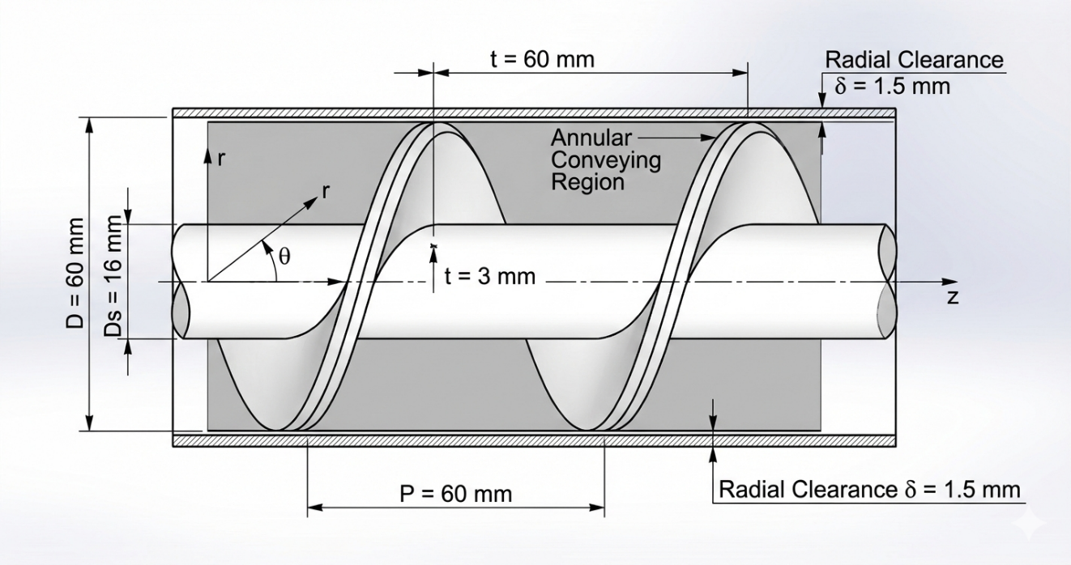
Figure 2.2.3: The figure clearly shows the ring transport area and the parametric coordinate system for defining the helical surface.

References
[1] Conveyor Equipment Manufacturers Association (CEMA). Screw Conveyor Engineering Guide. CEMA, Naples, FL.
[2] Roberts, A.W. (1999). "The Influence of Granular Vortex Motion on the Volumetric Performance of Screw Feeders," Powder Technology, 104(1), 56-67.
[3] Jenike, A.W. (1964). Storage and Flow of Solids, Bulletin No. 123. University of Utah Engineering Experiment Station.
[4] Nedderman, R.M. (1992). Statics and Kinematics of Granular Materials. Cambridge University Press.
[5] Schulze, D. (2008). Powders and Bulk Solids: Behavior, Characterization, Storage and Flow. Springer Science & Business Media.
2.2.4 Ideal Volumetric Displacement Theory
2.2.4.1 Theoretical Foundation and Fundamental Assumptions
The auger filling system is classified mechanically as a positive displacement pump for bulk solids. The ideal volumetric displacement theory establishes the theoretical relationship between angular rotation and discharged volume, predicated upon two fundamental physical assumptions that simplify the kinematic analysis of flow [1][2]:

Assumption 1: Complete Filling (100% Fill Factor)
The powder is assumed to completely fill the available void between screw flights and casing wall without irregular air pockets or void spaces.

Assumption 2: Zero Slip
The material is assumed to undergo pure axial translation without co-rotation with the screw or backward leakage through the clearance between flight tip and casing.

These idealizations define the theoretical upper bound for volumetric performance and establish the geometric foundation for control algorithm development in mechatronic filling systems [1][3].

2.2.4.2 Theoretical Volume per Revolution
Based upon the geometric model derived in Section 2.2.3, and neglecting the infinitesimal volume occupied by the flight material itself for mathematical simplification in ideal models, the theoretical volume of powder displaced during one complete revolution )$V_{th}$) is calculated by multiplying the effective cross-sectional area by the axial pitch:
$$V_{th}=\frac{π}{4}×\left(D^{2}-D_{s}^{2}\right)×P$$
Where theoretical displaced volume per revolution is $V_{th}$ (m³/rev), outer diameter of the screw is $D$ (m), shaft diameter is $D_{s}$(m), and screw pitch is $P$ (m)

This equation constitutes the fundamental basis of volumetric auger filling systems [1][2].

2.2.4.3 Flow Rate Equations
Volumetric Flow Rate:
For rotational speed $N$(rev/s), the theoretical volumetric flow rate $Q_{th }$becomes:
$$Q_{th }=V_{th}×N=\frac{π}{4}\left(D^{2}-D_{s}^{2}\right)×P×N$$
Mass Flow Rate:
Since vertical form-fill-seal (VFFS) packaging systems require control of dose weight rather than volume, the volumetric flow rate is converted to mass flow rate $\dot{m_{th}}$using the bulk density $ρ_{bulk}$ of the material being filled. As established in studies concerning volumetric feeding of powders, bulk density is the decisive factor in transforming volumetric behavior to gravimetric behavior [2][4]:
$$\dot{m_{th}=Q_{th }×ρ_{bulk}=\left[\frac{π}{4}\left(D^{2}-D_{s}^{2}\right)×P×N\right]ρ_{bulk}}$$
Mass Displacement per Revolution:
The theoretical mass delivered per revolution follows directly:
$$\dot{m_{th}=V_{th }×ρ_{bulk}=\left[ \frac{π}{4}\left(D^{2}-D_{s}^{2}\right)×P\right]×ρ_{bulk}}$$
These equations describe ideal kinematic-geometric flow only and establish the theoretical upper bound for system performance [1][3].

2.2.4.4 Mechatronic Control Equation
The ideal volumetric displacement theory provides the mathematical foundation for open-loop control algorithms in filling machines. To calculate the required filling time $T_{fill}$or the number of pulses to be sent to the servo motor to achieve a target weight $M_{target}$,the controller solves the following equation inversely [3][4]:
$$M_{target}=\dot{n_{rev}}×V_{th}×ρ_{bulk}$$
$$n_{rev}=\frac{M_{target}}{V_{th}×ρ_{bulk}}$$
where $n_{rev}$ represents the total number of revolutions required per package.

This formulation demonstrates geometrically that dosing accuracy in volumetric systems depends absolutely upon the constancy of bulk density $ρ_{bulk}$during operation. Any variation in compressibility or moisture content directly alters the final weight, even if the servo control system operates perfectly—a fundamental limitation that motivates the granular mechanical analysis presented in subsequent sections [2][4].

2.2.4.5 Real Displacement Behavior and Efficiency Factors
In real powder systems, actual discharge deviates from ideal behavior due to [3][4]:
- Slip between material and flight surface
- Non-uniform bulk density distribution
- Internal shear yielding and deformation
- Interparticle cohesion
- Incomplete feeding from the hopper
Thus, an empirical volumetric efficiency factor $η_{v}$is introduced:
$$V_{actual}=η_{v}×V_{th}$$
$$Q_{actual}=η_{v}×Q_{th}$$
$${\dot{m}}_{actual}=η_{v}×{\dot{m}}_{th}$$
where $0<η_{v}<1$ This efficiency factor depends strongly upon material flow properties, hopper feeding regime, and operational parameters [2][4].

2.2.4.6 Theoretical Limitations and Granular Material Behavior
The ideal volumetric displacement theory assumes:
1. Rigid plug flow without internal deformation
2. Constant, uniform bulk density
3. Steady, continuous feed conditions
4. Material incompressibility

Granular materials, however, may exhibit complex behaviors that violate these assumptions [3][4]:
- Dilatancy: volume expansion under shear
- Density variation: due to consolidation or aeration
- Arching: at the inlet causing intermittent flow
- Shear localization: non-uniform velocity profiles

Therefore, ideal volumetric theory provides a geometric upper bound and control system reference rather than an exact predictive model for real powder systems. The transition from this idealized framework to the actual granular mechanics of auger filling is addressed in Section 2.2.5.
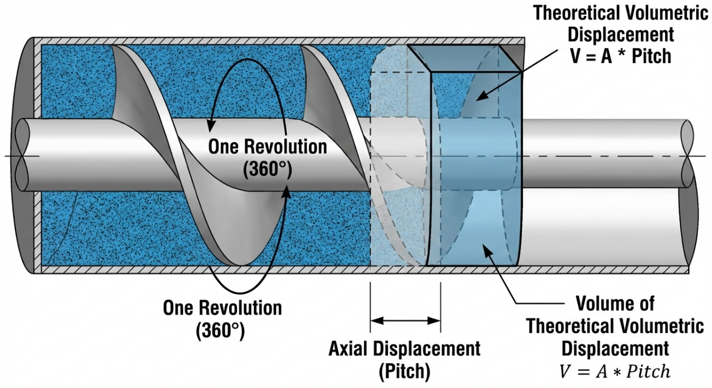
Figure 2.2.4: The schematic emphasizes the geometric relationship between angular rotation and discharged volume.

References
[1] Conveyor Equipment Manufacturers Association (CEMA). Screw Conveyor Engineering Guide. CEMA, Naples, FL.
[2] Roberts, A.W. (1999). "The Influence of Granular Vortex Motion on the Volumetric Performance of Screw Feeders," Powder Technology, 104(1), 56-67.
[3] Jenike, A.W. (1964). Storage and Flow of Solids, Bulletin No. 123. University of Utah Engineering Experiment Station.
[4] Nedderman, R.M. (1992). Statics and Kinematics of Granular Materials. Cambridge University Press.
2.2.5 Granular Mechanics Inside Screw Channels
2.2.5.1 Theoretical Foundation: Beyond Ideal Plug Flow
Contrary to the ideal geometric model which assumes material moves as a rigid plug ("nut on a screw"), the actual behavior of powders inside screw channels is governed by complex tribological interactions. The ability of the auger to pump material axially depends upon a delicate balance between friction forces acting on particles, as established by the classical theory developed by Roberts and Rademacher and recently validated through Discrete Element Method (DEM) simulations [1][2].

2.2.5.2 Friction Force Balance and Axial Transport Condition
For axial conveying to occur, particle rotation must be prevented. A single particle is subjected to two opposing forces:
- Screw surface friction force (Fscrew): Resulting from flight rotation, attempting to drag the particle in circular motion without forward progress
- Wall friction force (Fwall): Resulting from lateral pressure and centrifugal force, acting as a "brake" that prevents material rotation, forcing particles to slip on the flight surface and move forward [3]
The physical condition for flow to occur is:
$$F_{screw} <F_{wall}$$
If the material possesses high internal friction coefficient or adheres to the screw surface $(F_{screw} > F_{wall}),$ the material will rotate as a single rigid body (solid body rotation) and pumping ceases a phenomenon known as the "doughnut effect" [1].
Note: This explains the importance of the electropolished finish to the screw for reduce its angle of friction with pharmaceutical and food powders, as indicated by the studies of Hancock (2019).

2.2.5.3 Vortex Motion and Energy Dissipation
Studies using DEM techniques have demonstrated that particles do not move in straight lines but follow complex helical paths with localized circulation within a single pitch, contributing to material mixing but consuming portion of motor power as "parasitic torque" [2].

2.2.5.4 Back-flow Through Clearance
DEM simulations conducted by El Kassem (2021) proved that volumetric losses occur through the radial clearance (C) between flight tip and casing wall. This "back-flow" increases proportionally with rotational speed and with decreasing particle size [1].

This loss is modeled by a transport efficiency factor (${η }_{trans}$):
$${η }_{trans}= (Q_{ideal} - Q_{leak}) / Q_{ideal}= (V_{th} × N - Q_{leak}) / (V_{th} × N)$$
where $Q_{leak }$represents material escaping through the clearance. For this reason, the clearance in our design was limited to 1.5 mm maximum to minimize this loss.

2.2.5.5 Active and Passive Zones
Studies by Feng et al. (2022) indicate that material inside the auger does not move uniformly; a "passive zone" forms adjacent to the rotation axis, while effective motion concentrates in the "active zone" at flight peripheries [5]. This variation leads to fluctuation in discharged density, which the control system addresses through revolution count correction.

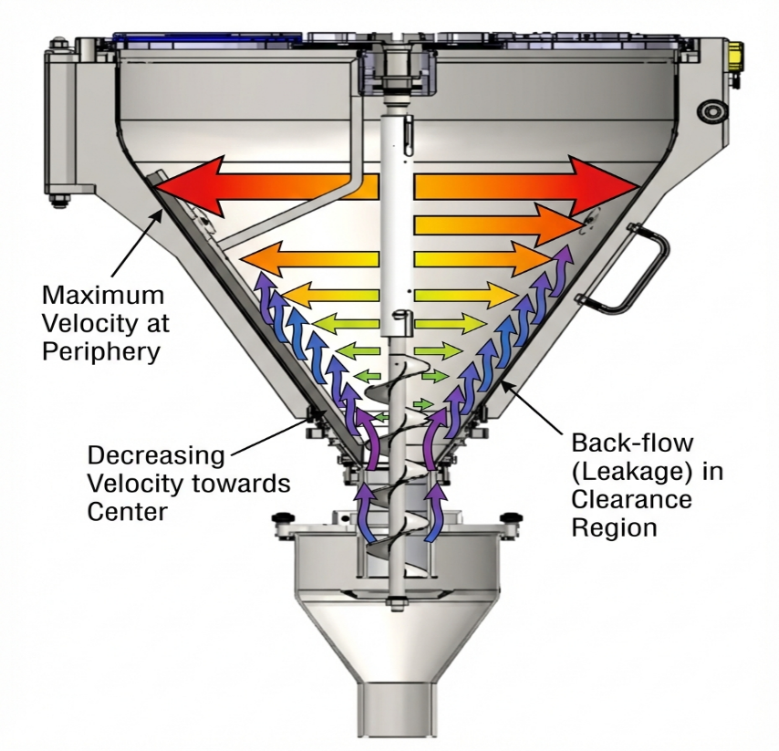
Figure 2.2.5: The image shows a diagram of the particle velocity distribution inside the hole.

2.2.6 Mechanism of Flow Control and Spinner Plate Theory
2.2.6.1 Theoretical Challenge: Free-flowing Material Control
Since salt is classified as a "free-flowing" material, it tends to self-discharge (dribbling) from the auger tip under gravity even when the motor stops. To prevent this phenomenon and ensure weight accuracy, the spinner plate mechanism fixed at the auger end was adopted, operating on the principle of balance between "centrifugal force" and "angle of repose" [2][6].

2.2.6.2 Dynamic State: Flow ON
When the auger rotates, the fixed spinner plate rotates at the same speed. Centrifugal force $(F_{c})$ is generated, pushing salt particles radially outward through the gap between the plate and the funnel lip.

The flow condition is described by:
$$F_{c}= m · ω² · r > F_{friction} + F_{cohesion}$$
Where is (m) a particle mass, ω angular velocity, is r radial distance from center, $F_{friction}$ friction force resisting motion, and $F_{cohesion}$interparticle cohesive force.

This force disperses material and ensures its exit in a regular conical pattern, assisting in salt distribution inside the bag [2].

2.2.6.3 Static State: Flow OFF
Upon auger stop, centrifugal force vanishes. The critical role of the "angle of repose" ($φ_{repose}$) of salt becomes dominant.

The gap between plate edge and funnel edge is designed such that accumulated material on the plate cannot slide because its surface slope is less than the angle of repose for salt $(φ_{repose} ≈ 35°).$

The accumulated salt forms what is termed a "natural product dam" that prevents leakage without requiring complex mechanical valves [2][6].

2.2.6.4 Geometric Stopping Condition
For the spinner plate to successfully stop flow, the gap geometry must satisfy:
$$tan⁻¹( h / L ) < φ_{repose}$$
where is a $\left(h\right)$vertical gap height and a $\left(L\right)$ahorizontal edge width of the plate.

This inequality ensures that the natural cone formed by stationary material has a slope less than the critical angle of repose, creating a self-sustaining blockage.

2.2.6.5 Operational Significance
The spinner plate represents a passive mechanical solution that enhances overall reliability of both weighing and packaging operations. Its radial ejection of material prevents concentration in a single path, and more importantly, the immediate flow cessation (zero dribbling) ensures the horizontal seal area remains free from any falling salt particles. Studies indicate that granular contamination in the heat sealing zone weakens seal strength and causes bag leakage making the spinner plate functionally critical for package integrity [2][6].

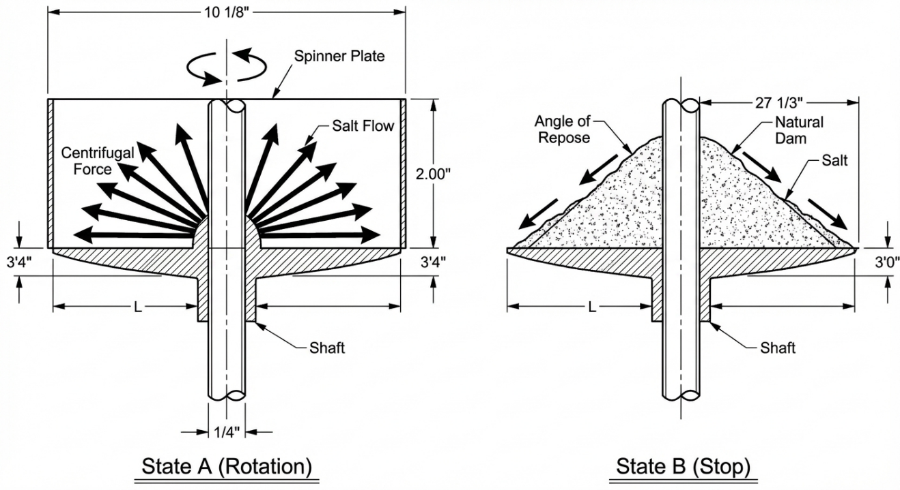
Figure 2.2.6: The image is a cross-sectional diagram illustrating the workings of a rotating plate:
State A (Rotation): Arrows radiating from center to periphery represent centrifugal force and salt flow
State B (Stop): Salt accumulated on the plate at an inclined angle (angle of repose) without falling, demonstrating the "natural dam" concept

References
[1] El Kassem, B. (2021). Machine Design for Auger Dosing of Powders by utilizing DEM Simulations. Ph.D. dissertation, RWTH Aachen University.
[2] All-Fill Inc. Universal Tooling: Straight Augers & Funnels Specifications. Form 653-3, Exton, PA.
[3] Bortolamasi, M., & Fottner, J. (2001). Design and Sizing of Screw Feeders. International Congress for Particle Technology (PARTEC), Nuremberg.
[4] Roberts, A.W. (1999). The influence of granular vortex motion on the volumetric performance of enclosed screw conveyors. Powder Technology, 104(1), 56-67.
[5] Feng, Y., et al. (2022). Granular dynamics in auger sampling. Journal of Fluid Mechanics.
[6] Woodcock, C.R., & Mason, J.S. (1987). Bulk Solids Handling: An Introduction to the Practice and Technology. Blackie Academic & Professional.
2.2.7 Slip, Compaction and Volumetric Efficiency
The ideal volumetric theory discussed in Section 2.2.4 assumes material transport occurs at $100\%$ efficiency, with powders behaving as incompressible fluids. However, in real industrial auger filling applications, actual flow rate deviates significantly from theoretical predictions due to three interrelated mechanical phenomena: back-slip, powder compressibility, and dynamic speed effects [1][2].

2.2.7.1 Back-Slip Phenomenon
Back-slip is defined as the reverse motion (or leakage) of powder particles in the direction opposite to the main flow. This phenomenon occurs primarily through the radial clearance ($δ$) between the flight tip and the inner wall of the outer casing.

This clearance cannot be eliminated mechanically to avoid metal-to-metal contact, yet its existence creates a leakage path. The amount of reverse flow$(Q_{slip})$depends on the axial pressure gradient $(Δ_{Paxial})$ and particle size relative to clearance dimensions. Consequently, the net volumetric flow rate ($Q_{net}$) is given by:
$$Q_{net} = Q_{ideal} -Q_{slip}$$
For highly free-flowing powders such as salt, slip rate increases with larger clearance. For cohesive powders, the clearance region may become blocked by a solidified layer (dead layer), reducing slip but increasing friction torque [1][2].

2.2.7.2 Powder Compaction and Density Variation
Powders are inherently compressible materials. Research in bulk solids mechanics by Schulze and others demonstrates that bulk density ($ρ_{bulk}$) is not a constant physical property, but rather a function directly dependent on consolidation stress ($σ1$) applied to the powder [2][3].

During filling operations, powder inside the auger is subjected to three compaction sources:
- Hydrostatic head pressure: Weight of material column in the hopper above the auger. This pressure varies with material level, causing density variation from start to end of operation.
- Kinematic compaction: Helical flights pushing material forward generate pressure that compresses particles together, reducing voidage/porosity.
- Vibration consolidation: Mechanical vibrations from the machine cause particle rearrangement into denser packing configurations.
This instantaneous density change (${Δρ}_{bulk}$) represents the largest contributor to weight accuracy deviation in volumetric fillers, where displaced volume remains constant but mass of that volume changes with material compaction [2][3].

2.2.7.3 Volumetric Efficiency
To integrate slip and compaction effects into a single applicable mathematical model for engineering design, a dimensionless parameter termed volumetric efficiency (${η }_{v}$) is employed. This parameter is defined as the ratio between measured actual flow rate and geometrically calculated theoretical flow rate:
$${η }_{v}={ Q}_{actual} / Q_{ideal} = m_{actual} / m_{ideal}$$
The theoretical volumetric displacement per revolution (Section 2.2.4): $V_{tideal}=A_{c}×P$
Actual volumetric discharge: $V_{actual}={η }_{v}×V_{ideal}$
The value of ${η }_{v}$ is affected by auger rotational speed ($N$). Experimental curves indicate that volumetric efficiency is low at very slow speeds (due to slip and leakage dominance), reaches peak at moderate speeds, then declines at very high speeds (due to material inability to fill inter-flight voids rapidly enough, termed starvation effect) [1][4].

Volumetric efficiency is influenced by a Rotational Speed ​​($N$), Radial Clearance ($δ$), Hopper Fill Level / Head Pressure, Powder Properties, and an Auger Geometry
Thus:
$$η_{v}=f(μ_{w}​,ϕ,ρ_{bulk},N,D,P,δ)$$
It is a multivariable function of friction, internal angle of friction, density, speed, diameter, and pitch.
In industrial dosing system design, effective volumetric efficiency typically ranges from 0.4 to 0.9. This deficiency is compensated programmatically through the control system by calibrating motor revolution count for each specific product [2][4].

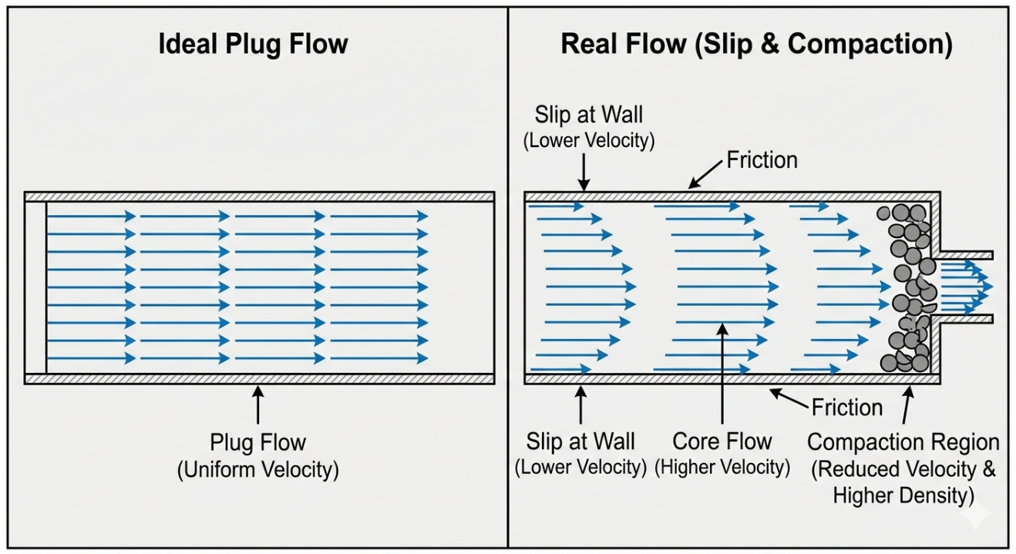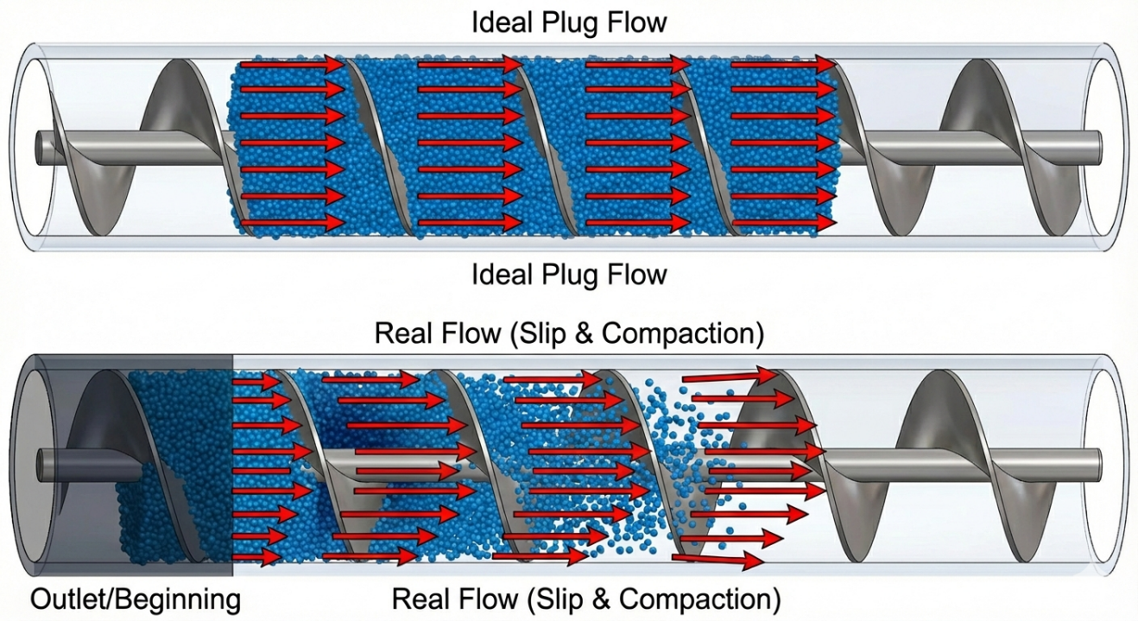
Figure 2.2.7: The figure visually compares ideal and real flow behavior.

2.2.8 Classification of Auger Filling Systems
To overcome the mechanical and dynamic challenges previously discussed, the auger filling machine industry has evolved to offer several configurations suited to product nature and required accuracy. These systems may be classified according to two primary criteria: drive mechanism and measurement principle [5][6].

2.2.8.1 Classification by Drive Mechanism
- Clutch-Brake Systems: Traditional systems where the motor runs continuously and the auger is engaged/disengaged mechanically. These systems suffer from continuous mechanical wear and inaccurate auger stopping position due to inertia.
- Stepper Motor Systems: Provide better angular position control compared to clutch systems, but may experience missed steps under high loads or high speeds.
- Servo-Driven Systems: Represent the modern industrial standard with highest precision. Through feedback from the encoder, precise control of auger angular position, acceleration, and deceleration is achieved, significantly reducing inertia errors and over-spillage. (Note: This is the system adopted in our current design) [5][6].

2.2.8.2 Classification by Measurement Principle
- Volumetric Filling: The system rotates the auger for a predetermined number of revolutions or pulses to displace a specific material volume. This system assumes constant powder bulk density. It features high speed but accuracy decreases if powder properties change.
- Gravimetric Filling: The auger is integrated with load cells measuring actual mass. The system may be fill-by-weight (weighing the filled container) or loss-in-weight (weighing the entire feed hopper). This system is slower but ensures very high accuracy as it automatically corrects for any changes in compressibility density [5][6].

2.2.8.3 Classification by Geometry
- Single Flight Screws: Standard helical design.
- Twin-Screw Systems: Used for cohesive or difficult powders.
- Variable Pitch Screws: Pitch decreases toward discharge to improve compaction control.

2.2.8.4 Classification by Industrial Application
- Food powders
- Pharmaceutical powders
- Chemical powder
- Mineral powders
Material properties dictate screw design selection.

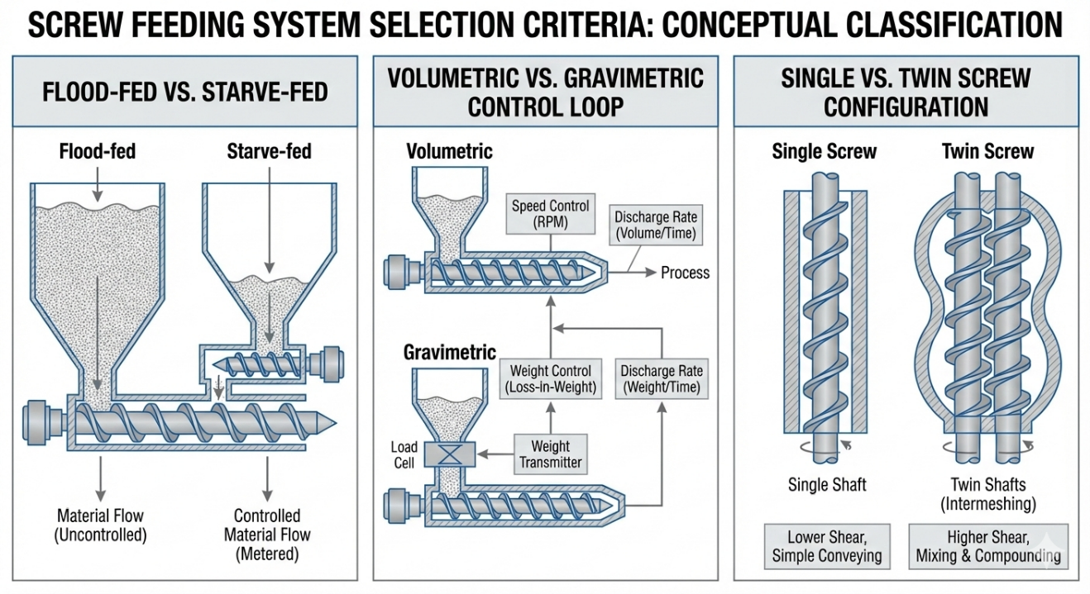
Figure 2.2.8: This conceptual classification figure illustrates system selection criteria.

References
[1] Rademacher, F.J.C. (1980). "On the theory of screw conveyors." Proc. 1st Int. Conf. on Design and Application of Screw Conveyors.
[2] El Kassem, B. (2021). Machine Design for Auger Dosing of Powders by utilizing DEM Simulations. Ph.D. dissertation, RWTH Aachen University, Germany.
[3] Kruppa, F., Weiss, U., Oberdorfer, B., & Wilke, B. (2022). "Increasing the dosing accuracy of a screw dosing device by inline measurement of the product density." Packaging Technology and Science, vol. 35.
[4] Schulze, D. (2008). Powders and Bulk Solids: Behavior, Characterization, Storage and Flow. Springer Science & Business Media.
[5] All-Fill Inc. Universal Tooling: Straight Augers & Funnel Dimensions (Form 653-3), Exton, PA.
[6] Boriack, C. (2011). "Adaptive Modeling for Weight Control in Vertical Auger Filling Applications of Food Powders." ASABE Annual International Meeting, Paper No. 1111578, Louisville, Kentucky.
2.2.9 Theoretical Limitations of the Ideal Model
The "ideal volumetric displacement" model (explained in section 2.2.4) assumes an ideal case where: a Perfect plug flow, Constant bulk density, No slip between powder and screw,Fully filled screw channel, No air entrainment, No particle segregation

However, real granular systems deviate from these assumptions due to fundamental physical limitations inherent to bulk solids behavior [1][2]. This section establishes the theoretical boundaries of accuracy for volumetric auger filling systems.

1. Density Variability
In the ideal model:
$$m = ρ · V$$
where$ρ$ is assumed constant.
In reality:
$$ρ = f(σ, t, v, moisture, vibration)$$
Bulk density varies due an Overburden stress,Shear compaction, Hopper residence time, Moisture content, and Machine vibration

Density fluctuations directly translate into mass dosing error:
$$Δm = V × Δρ$$
Even if volumetric displacement is perfectly repeatable, density variation alone limits achievable accuracy [3].

2. Slip-Induced Volume Loss
From Section 2.2.7:
$${V }_{act}= {η }_{v}· V_{ideal}$$
Slip changes ($η_{v}$) dynamically. Slip is influenced by Wall friction coefficient ($μ_{w}$), Internal friction angle ($φ$), and Rotational speed ($N$)

Since these parameters are not constant during operation, volumetric efficiency fluctuates. Thus: $η_{v} = η_{v} (t)$
This introduces dynamic dosing variation even under constant screw rotation [1][4].

3. Partial Filling and Starvation
In starve-fed systems:
$$V_{ideal} = A_{c} × P × f$$
where$f = filling ratio$
If $f < 1$, actual displacement reduces proportionally. However, f is not constant due a Hopper discharge instability, Arching and ratholing, and Powder consolidation.

Therefore:
$$m = ρ ×{ A}_{c}× P × f$$
Any fluctuation in f directly alters output mass [2][4].

4. Air Entrainment and Void Fraction
Granular materials contain void spaces. Let:
$$ε = void fraction$$
Bulk density: $ρ = (1 - ε)ρs$
where$ρs = solid particle density$
Changes in void fraction during compaction alter effective density. Air compression effects become significant at higher screw speeds [4].

5. Particle Segregation
During the rotation of the helix, the fine particles tend to migrate downwards and the coarser particles upwards. This creates an axial density gradient, $ρ(z) ≠ constant$ resulting in a non-uniform mass for each helix rotation [2].

6. Electromechanical Dynamics and Kinematic Inertia
The ideal model assumes steady-state rotation. In reality, however, there is Acceleration phase, Deceleration phase, Micro-stops, and Motor torque ripple
Angular acceleration:
$$α = dω/dt$$
During transient motion, material inertia modifies internal stress distribution. Thus:
$$T = T_{steady} + T_{inertia}$$
Dynamic torque fluctuations slightly alter discharge per cycle [5].

Furthermore, the ideal kinematic equation implicitly assumes instantaneous start/stop. Physically, the mechanical system (motor, gearbox, auger shaft filled with powder) possesses mass moment of inertia $(J).$
The relationship of mass to rotational speed:
$$Q_{m}=ρ_{eff}×η_{v}×A_{c}×P×n$$
$${m=Q}_{m}×t_{f}$$
When the controller issues a stop command, the motor continues rotating for a brief spindown time before complete stopping, resulting in additional material discharge known as "in-flight material" or dribble [5]:
$${Δm}_{dribble} = \dot{m} · {Δt}_{delay}$$
where${Δt}_{delay}$is the mechanical and electronic response delay time.

7. Mechanical Manufacturing Tolerances
The ideal geometric model assumes an ideal case when: a Perfect concentricity, Constant pitch, and Uniform clearance

In practice: a Shaft runout, Flight thickness variation, Clearance tolerance

All affect effective channel volume:
$$ΔV = f(manufacturing tolerance)$$

8. Environmental Variables and Caking
As noted in material properties (Section 2.1.1), sodium chloride is highly sensitive to relative humidity (RH). Daily factory humidity changes alter cohesion forces between particles, changing internal friction angle ($φ$) and thus slip factor within the auger [3].

9. Theoretical Accuracy Limits and Design Implications
By combining all previously discussed error sources, the actual mass output can be modeled as:
$$ε=\frac{Δm}{m}​$$
$$ε=\frac{{ ​m}_{actual}-m_{target}}{m_{target}}​​​$$
$$m_{actual} = ρ × A_{c} × P × η_{v} × f$$
Since each term in this equation is variable during operation, the total relative mass error is derived as:
$$Δm/m = Δρ/ρ + Δη_{v}/η_{v} + Δf/f + ΔV/V$$
Even under optimized industrial conditions, purely volumetric auger systems typically achieve an accuracy ranging from $±0.5\% to ±2\%$ ,depending on powder properties [5][6]. This represents the theoretical lower bound of achievable dosing accuracy without gravimetric feedback.

The ideal volumetric displacement model is deterministic, geometrically derived, and highly useful for first-order mechanical design. However, real-world performance requires experimental calibration, empirical efficiency factors, or closed-loop gravimetric correction. Therefore, the ideal model must be interpreted as a baseline engineering approximation rather than an exact predictor of mass output.

Summary and design direction of the project:
This theoretical analysis demonstrates that relying on "open-loop control "that is, rotating the screw a fixed number of turns and blindly predicting an exact weight is an inadequate engineering approach, incapable of dynamically compensating for inherent volumetric distortions. To achieve the rigorous industrial accuracy required in this project, the scientific basis necessitates a shift from a volumetric model to an "adaptive gravimetric model." This requires integrating a load cell and implementing a closed-loop PID control algorithm via a highly responsive microcontroller (such as the ESP32). This mechatronic system will sense and correct errors in real-time by adjusting the motor's angular position to compensate for any changes in density or slip, a process that will be detailed mathematically and practically in subsequent chapters on design and control.

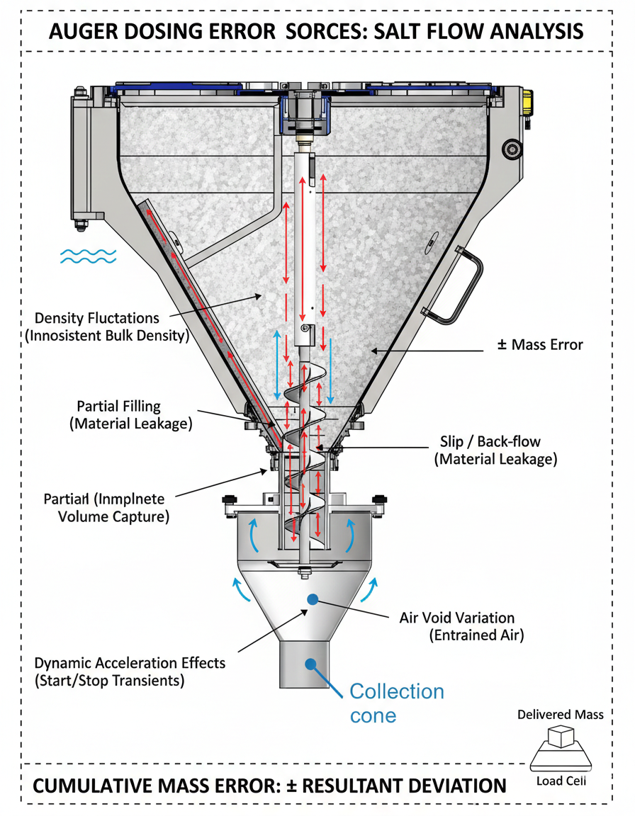
Figure 2.2.9: Arrows indicating contribution to mass error.

References
[1] Jenike, A.W. Storage and Flow of Solids. University of Utah Engineering Experiment Station.
[2] Nedderman, R.M. Statics and Kinematics of Granular Materials. Cambridge University Press.
[3] Kruppa, F., Weiss, U., Oberdorfer, B., & Wilke, B. (2022). "Increasing the dosing accuracy of a screw dosing device by inline measurement of the product density." Packaging Technology and Science, vol. 35.
[4] Roberts, A.W. "Granular Flow in Screw Feeders." Powder Technology.
[5] Boriack, C. (2011). "Adaptive Modeling for Weight Control in Vertical Auger Filling Applications of Food Powders." ASABE Annual International Meeting, Paper No. 1111578.
[6] El Kassem, B. (2021). Machine Design for Auger Dosing of Powders by utilizing DEM Simulations. Ph.D. dissertation, RWTH Aachen University.
[7] Hohmann, H.J. (1988). "Filling characteristics and dosing accuracy of volumetric dosing devices in vertical form fill seal machines." Packaging Technology and Science, 1(3), 123-135.

CHAPTER 4 – SYSTEM REQUIREMENTS AND ENGINEERING SPECIFICATIONS

4.3 Mechanical Requirements
4.3.1 Auger, Shaft, and Rotary Plate Subsystem
This section defines the mechanical engineering requirements of the powder dosing subsystem responsible for volumetric metering inside the VFFS machine. The subsystem consists of the auger screw, auger shaft, integrated bottom rotary plate (anti-dribble plate), and torque transmission interface. These requirements are based on the theoretical volumetric displacement as explained in the previous section, the static structural analysis and full torque-detailed calculations in subsequent chapters, and the target of operational dose accuracy $(±1.5\%).$ All requirements are measurable and analytically justified.

4.3.1.1 Functional Mechanical Requirements
Volumetric Delivery: The auger shall deliver the required mass per cycle according to the analytical volumetric displacement model $m = ρ× V_{eff}$, where $V_{eff}$ includes volumetric efficiency corrections.
Operating Speed: The nominal rotational speed of the auger shall be $n = 135 rpm$, derived from throughput requirements and volumetric modeling.
Synchronous Rotary Plate Operation: The bottom rotary plate shall be rigidly coupled to the auger shaft and rotate at the same angular velocity$n_{plate} ={ n}_{auger} = 135 rpm$. No independent actuation is permitted.
Post-Stop Powder Containment: Upon motor stop command, the rotary plate shall prevent uncontrolled gravitational discharge, contain residual powder trapped in the lower screw channel, and reduce post-stop dosing error. The acceptable residual mass error after stop shall not exceed ${Δm}_{residual} ≤ 1\%$ of target mass.

4.3.1.2 Geometrical and Tolerance Specifications
To implement the square pitch theory ensuring consistent flow of free-flowing materials, the following strict geometric specifications are established for the auger and funnel:

Outer Diameter (D): $60 mm$ maximum, compatible with available packaging film width and target bag size
Shaft Diameter (d): 16 mm, ensuring sufficient torsional rigidity to withstand motor torque without deflection during operation
Radial Clearance (C): The most critical dimension to prevent back-flow of salt. The clearance between auger flight tip and inner tube wall shall not exceed $1.5 mm$ prevent the free-flow (flushing) of fine salt particles when the screw is stationary, requiring precision machining of the tube to ensure ideal circularity

4.3.1.3 Torque Transmission Requirements
The auger, shaft assembly shall transmit the full calculated torque:
$$T_{raw} = {T }_{weight}+ T_{axial} + T_{shear} +{ T}_{friction }+{ T}_{inertia} + T_{plate}$$

The design torque shall satisfy$T_{design} ={ T}_{raw} × SF$with safety factor $SF ≥ 1.8$. Maximum torsional shear stress shall satisfy ${τ }_{max}= 16×T/(πd³) ≤ τ_{allowable}$.

Gearbox reduction ratio:
$$1:20$$
Motor selection shall satisfy:
$${T }_{motor }× i × n ≥ T_{ design}$$

4.3.1.4 Structural Integrity Requirements
The subsystem shall withstand combined loading including torsional torque, axial compressive force, distributed friction loading, and transient inertial loading. Von Mises stress requirement: $σ_{vm} ≤ σ_{yield}/SF$. Maximum allowable tip deflection: ${δ }_{tip}≤ 0.1$ mm to ensure geometric stability of volumetric pockets.

4.3.1.5 Dynamic Stability Requirements
Critical Speed Margin: The shaft critical speed shall satisfy $n_{critical} ≥ 1.3 × 135 rpm$ to prevent resonance during operation.
Rotational Stability: Radial runout at screw $tip ≤ 0.03 mm$. Maximum vibration $amplitude ≤ 0.05 mm.$

4.3.1.6 Rotary Plate Functional Requirements
The rotary plate shall provide geometric closure of the lower screw exit, support transient material load during stop condition, avoid inducing reverse compaction in the screw channel, and maintain rotational balance at 135 rpm. The plate shall not introduce additional torque exceeding 5% of total torque budget.

4.3.1.7 Material and Environmental Requirements
Given salt's corrosive nature and hygroscopic properties, material selection is subject to:
- Material of Construction: All product-contact parts (hopper, auger, funnel tube, rotary plate) shall be manufactured from food-grade stainless steel , providing excellent chloride resistance compared to $SS304$
- Surface Finish: Internal surfaces of hopper and auger surfaces shall undergo high-smoothness mechanical polishing (polished mirror finish / 2B finish) to reduce wall friction$μ_{wall}$ and prevent salt bridge formation

4.3.1.8 Agitation and Flow Conditioning Requirements
To achieve mass flow regime and prevent ratholing discussed in fundamental theory, the mechanical system requires:
- Independent Agitation System: The hopper shall be equipped with a separate agitator motor operating continuously to separate agglomerated particles, break mechanical bridges, and ensure auger flights are fed with constant bulk density
- Anti-Dribble Mechanism: The auger end shall be equipped with a rotary spinner plate with diameter and angle compatible with salt angle of repose φr, ensuring material flow stops immediately upon auger rotation cessation without complex pneumatic valves

4.3.1.9 Maintenance, Hygiene, and Assembly Requirements
In industrial food packaging, downtime for cleaning and product changeover must be minimized. The mechanical design shall follow Clean-Out-of-Place (COP) standards. The hopper, auger, and funnel shall be assembled using quick-release mechanisms (Tri-Clamp fittings or hand-wheels) allowing complete disassembly, cleaning, and reassembly by a single operator without external tools (No-Tools Assembly).

Table 4.3 — Mechanical Requirements
Auger, Shaft, and Rotary Plate Subsystem
ID | Requirement Category | Mechanical Requirement | Quantitative Target / Constraint | Engineering Justification | Verification Method
MR-01 | Functional | The auger shall deliver the target powder mass per cycle using volumetric displacement theory. | $$m = ρ × V_{eff}$$ | Derived from ideal displacement model (Chapter 2) | Analytical + DEM
MR-02 | Speed | Nominal auger rotational speed | $$135 rpm$$ | From throughput calculations | Motion simulation
MR-03 | Kinematic Coupling | Rotary plate shall rotate synchronously with auger | $$n_{plate }= 135 rpm$$ | Direct mechanical coupling | CAD verification
MR-04 | Post-Stop Containment | Rotary plate shall prevent uncontrolled powder discharge after stop | $$Residual error ≤ 1\%$$ | To eliminate dribble error | Experimental validation
MR-05 | Torque Capacity | Shaft shall transmit total calculated torque | $$T_design ≥ T_raw × SF$$ | From torque breakdown (Ch.13) | Analytical
MR-06 | Safety Factor | Minimum torsional safety factor | $$SF ≥ 1.8$$ | Industrial rotating equipment practice | Analytical
MR-07 | Shear Stress Limit | Maximum torsional shear stress | $$τ_max ≤ τ_allowable$$ | τ = 16T / πd³ | Static FEA
MR-08 | Structural Strength | Von Mises stress limit | $$σ_vm ≤ σ_yield / SF$$ | Prevent yielding | FEA
MR-09 | Deflection Limit | Maximum axial tip deflection | $$δ ≤ 0.1 mm$$ | Preserve volumetric geometry | FEA
MR-10 | Critical Speed | Critical speed margin | $$n_cr ≥ 1.3 × 135 rpm$$ | Avoid resonance | Analytical
MR-11 | Runout Limit | Maximum radial runout | $$≤ 0.03 mm$$ | Dosing repeatability | Measurement
MR-12 | Vibration Limit | Maximum vibration amplitude | $$≤ 0.05 mm$$ | Stability requirement | Motion analysis
MR-13 | Surface Finish | Flight surface roughness | $$Ra ≤ 1.6 µm$$ | Reduce friction variability | Manufacturing spec
MR-14 | Material | Corrosion-resistant material | SS304 or equivalent | Salt handling | Datasheet
MR-15 | Rotary Plate Load | Plate shall withstand transient material load during stop | No yielding | Containment function | FEA
MR-16 | Torque Contribution | Rotary plate torque contribution | $$≤ 5\% of total torque$$ | Avoid oversizing motor | Analytical
MR-17 | Dynamic Inertia | Auger inertia shall not exceed motor transient capability | T_inertia within motor peak torque | Startup analysis | Motion sim
MR-18 | Dimensional Accuracy | Flight pitch and diameter tolerance | ±0.05 mm | Preserve volume accuracy | CAD + Inspection
MR-19 | Alignment | Shaft concentricity | ≤ 0.02 mm | Reduce vibration | Assembly check
MR-20 | Thermal Stability | No dimensional distortion under operating temperature | $$Δd negligible$$ | Maintain dosing | Material property

Figure 4.3.1: 2D CAD drawing with dimensioned views showing auger specifications (D=60 mm, d=16 mm, C=1.5 mm), preferred SolidWorks drawing.

4.4 Motion and Speed Requirements
The accuracy of the volumetric auger filling process is fundamentally dependent on the kinematic profile of the auger shaft. To achieve the target fill weight of$500 g$ of NaCl efficiently and accurately to achieve the target weight accuracy $(±1.5\%),$ the electromechanical drive system comprising a servo motor coupled with a $1:20$planetary gearbox must adhere to the following motion and speed criteria:

4.4.1 Operating Speed and Throughput
- Optimal Shaft Speed: The rotational speed of the auger must be optimized to balance production throughput (target fills per minute) with powder stability. Operating the auger at excessively high speeds can cause centrifugal fluidization of the salt particles, which significantly alters the bulk density and leads to unpredictable dosing volumes.
- System Kinematics: Given a standard industrial servo motor operating at a rated speed of $3000 RPM$, the $1:20$ reduction ratio yields a maximum effective auger shaft speed of 150 RPM. This specific speed range provides a controlled flow regime suitable for granular NaCl, allowing for rapid dosing without degrading the crystalline structure of the salt or inducing erratic mass flow.
4.4.2 Dynamic Response (Acceleration and Deceleration)
Due to the effect of "kinematic inertia" (explained in section 2.2.9) on filling accuracy, the screw motor must not be operated in a sudden (on/off) pattern.
- Motion Profiling: The primary controller (ESP32) must be capable of generating precise motion trajectories typically trapezoidal or S-curve profiles to command the servo drive smoothly, minimizing mechanical jerks that could cause powder to compact unevenly within the screw flights.
- Rapid Deceleration: The most critical phase of the dosing cycle is the stopping mechanism. The drive system must possess high dynamic braking capabilities to decelerate from its operational speed to a dead stop almost instantaneously. Any motor coasting or mechanical lag at the end of the cycle will result in powder "giveaway" (overfilling), thereby violating the acceptable weight tolerance limits.
4.4.3 Positional Accuracy and Resolution
- Angular Displacement: In auger fillers, the dispensed mass is directly proportional to the total angular displacement $\left(∅\right)$of the screw. The target weight of $500 g$ corresponds to a mathematically defined number of auger revolutions based on the screw's displaced volume per pitch.
- Encoder Feedback: To achieve precise volumetric control, the prime mover must utilize high-resolution encoder feedback. This ensures that the angular positioning is strictly governed, eliminating cumulative rotational errors over continuous filling cycles and ensuring high repeatability.
4.4.4 Torque-Speed Stability
- Constant Torque Delivery: The selected drive train must provide a relatively flat torque-speed curve within its operating range. It must deliver sufficient breakaway torque to initiate the movement of the compacted salt bed at rest, and maintain a constant angular velocity $(ω)$ during the filling phase, regardless of minor fluctuations in powder head pressure or localized friction inside the enclosing tube.

Summary of Motion Requirements (For Table Insertion)
ID | Requirement | Value
MR-M1 | Nominal Speed | 135 rpm
MR-M2 | Speed Stability | ±1%
MR-M3 | Angular Resolution | ≤ 0.5°
MR-M4 | Stop Time | ≤ 50 ms
MR-M5 | Timing Sync | ≤ 5 ms
MR-M6 | Safety Margin vs Critical Speed | ≥ 25%
MR-M7 | Motion Profile | S-curve

4.6 Accuracy and Dosing Requirements
The primary function of the auger filling system is to divide bulk material (sodium chloride - NaCl) into precise and equal mass doses. To ensure industrial viability and compliance with vertical form-fill-seal (VFFS) machine standards, the system must satisfy the following stringent requirements regarding weight, accuracy, and speed.

4.6.1 Target Weight and Permissible Tolerance
Target Dose Capacity: The system is designed to process and fill packages with a net target weight of $500 grams$ of salt per filling cycle.
Legal and Industrial Tolerance: According to International Organization of Legal Metrology (OIML R 87) standards for pre-packaged goods, the maximum permissible error (MPE) for 500 gram packages shall not exceed $±1.5\% to ±3\% maximum.$ The designed system shall achieve dosing accuracy of $±1\%$ (i.e.,$±5 grams$) for $500 gram$ weight. Achieving this narrow margin requires minimizing all volumetric error sources such as slip and free-fall dribbling analyzed in Chapter 2.

4.6.2 Repeatability and Statistical Stability
The engineering requirement extends beyond achieving accurate weight in a single cycle to "repeatability" across hundreds of consecutive cycles. The system must maintain low standard deviation $(σ)$. Dose stability must not be affected by minor changes in powder level inside the hopper (hopper head pressure), necessitating effective mechanical design of the agitator mechanism to maintain homogeneous bulk density of salt before entering the auger channel.

4.6.3 Cycle Time and Throughput
Since this system is an integral part of a VFFS machine, the dosing time represents a critical constraint; powder discharge must be completed while the plastic bag is in the forming and bottom sealing phase.
Temporal Requirement: The $500 gram$ dose must be displaced within time not exceeding$1.0 to 1.5 seconds$. This temporal constraint imposes severe requirements on the servo motor to reach maximum speed (acceleration) and return to complete stop (deceleration) in fractions of a second without inducing resonant structural vibrations.

4.6.4 Dynamic Resolution and Control Precision
To achieve $±5 gram$accuracy theoretically and practically, the "smallest mass the machine can control" ($m_{min}-minimum controllable mass$) must be much smaller than this value. This requirement necessitates integration of a precision controller with instantaneous response (ESP32) with a motor possessing high-resolution feedback encoder. The system must be capable of converting each required gram into a specific and very small number of pulses, ensuring no overshoot occurs at target weight.

4.6.5 Closed-Loop Control and Dosing Strategy
To overcome kinematic inertia and slip (as explained in Section 2.2.9), open-loop filling must not be relied upon. Instead, a closed-loop feedback control system must be implemented adopting a "two-stage filling" strategy (bulk and trim filling):
Bulk Fill Phase: The auger rotates at maximum operating speed to fill the majority of the package (approximately $90-95\%$ of target weight) in the shortest possible time to ensure high productivity.
Trim Fill Phase: Once weight reaches the predetermined value, motor speed drops sharply, and the auger rotates slowly and intermittently (dribble) to complete the remaining$5\%$ with extreme precision based on instantaneous load cell readings, until reaching final weight and immediate flow cessation.

4.6.6 Dynamic Calibration and Feed-Forward Requirements
Continuous Density Compensation: Given the probability of salt density variation $(ρ_{bulk}),$the precision controller (ESP32) must include software algorithm based on "adaptive learning." The algorithm compares "actual weight" with "expected weight" after each package, automatically updating the "pulses-per-gram ratio" for the next package, eliminating need for continuous manual calibration.
In-Flight Material Compensation: The controller must predict the amount of salt "suspended in air" (in-flight) that will fall after motor stop command is sent. The cut-off point must be programmed to be less than target weight by amount equal to free-fall weight.
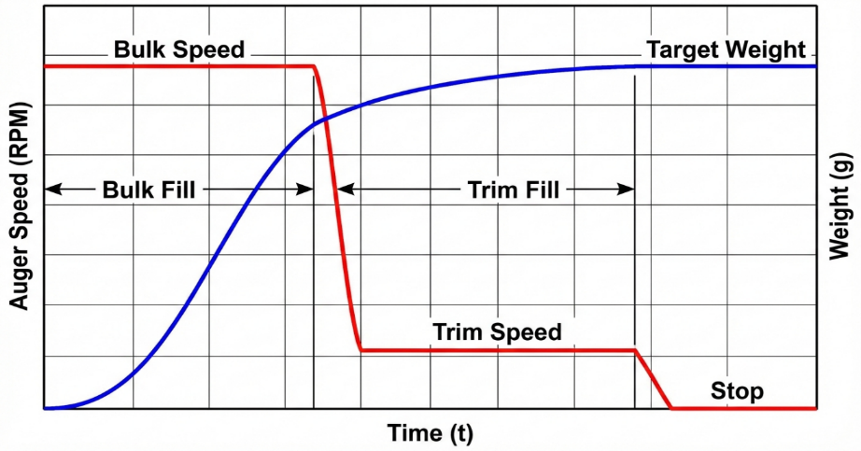
Figure 4.6.1: Graph illustrating bulk and trim strategy. Horizontal axis represents time $(t),$ vertical axis represents auger speed (RPM) or weight ($g$).

Requirement Traceability Matrix
ID | Requirement | Source | Verification
ADR-01 | $500 g$ target weight | Packaging requirement | Weighing test
ADR-02 | ±1% accuracy $(±5 g)$ | OIML R 87 + design margin | Statistical sampling
ADR-03 | $σ ≤ 1\%$ repeatability | Industrial practice | 50-cycle test
ADR-04 | $1.0-1.5 s$ dosing time | VFFS cycle constraint | Timing measurement
ADR-05 | Two-stage filling strategy | Control theory | Algorithm implementation
ADR-06 | Adaptive density compensation | Bulk density variation | Software validation
ADR-07 | In-flight compensation | Kinematic inertia theory | Experimental tuning

4.8 Safety, Reliability, and Compliance Requirements
The auger filling subsystem operates at high rotational speeds, generates significant torque, and processes consumable food products (sodium chloride). Therefore, the mechanical and electromechanical design must strictly adhere to industrial safety regulations, sanitary compliance, and reliability standards.

4.8.1 Food Safety and Hygienic Compliance
Since the machine packages food intended for human consumption, it must comply with general sanitary design principles including FDA guidelines and ISO 22000 standards for food safety.

Material Compliance: As specified in Section 4.3, all internal components must be food-grade stainless steel (304/316L). The use of any rust-prone or chemically reactive materials in salt-contacting parts is strictly prohibited. Stainless steel 316L is mandated for all parts (auger, hopper, funnel, agitator) due to its high resistance to pitting corrosion caused by chloride ions in salt.

Lubrication Isolation: All mechanical bearings, gearboxes, and servo-motor couplings must be strictly isolated from the powder flow zone. Any lubricants used in proximity to the hopper must be H1 food-grade lubricants to prevent toxic contamination in the event of seal failure.

Dead-Zone Elimination: The geometric design of the hopper and auger flights must minimize internal crevices or "dead zones" where salt could accumulate, stagnate, or cause localized galvanic corrosion over time. The auger and hopper must be designed free of "dead zones" or sharp corners where salt and bacteria might accumulate. Auger assembly must feature quick-release mechanism to facilitate mechanical cleaning (COP - Cleaning Out of Place) without complex tools.

Cleanability: The design must follow Clean-Out-of-Place (COP) standards with quick-release mechanisms allowing complete disassembly, cleaning, and reassembly by a single operator without external tools.

4.8.2 Reliability and Overload Protection
Industrial VFFS machines are expected to run continuously for long shifts with high overall equipment effectiveness (OEE). The system must be resilient against internal mechanical faults.

Jamming and Over-Torque Protection: Salt caking or accidental introduction of foreign objects can cause auger jamming. To prevent catastrophic failure (shaft twisting, motor burnout, or structural fracture), the control system must continuously monitor servo motor current draw. The ESP32 must be programmed with peak current threshold correlating to maximum allowable torque. If this threshold is exceeded, the system must trigger automatic fault state, stopping motors and alerting operator via IoT HMI dashboard.

Abrasive Wear Resistance: Salt crystals are abrasive materials. Continuous friction between salt and outer edges of flights will cause metal wear and increased radial clearance over time. Lower edges of auger must be hardened or scheduled as "consumable parts" with periodic clearance measurement and replacement after specified operating hours to maintain $±1.5\%$ accuracy.

IP Rating: Due to fine salt dust capable of damaging electronic circuits, auger motors (stepper/servo) and wire junction boxes around load cell must have protection rating not less than IP65, ensuring complete isolation from dust and water spray during washing.

Vibration and Fatigue: The frame supporting the auger drive mechanism must be sufficiently rigid to dampen high-frequency vibrations caused by agitator breaking salt bridges, ensuring long fatigue life for mechanical joints and precise load cell readings. Shaft fatigue life must exceed ${10}^{7}$ load cycles based on repeated torque cycles, start-stop operation, and powder resistance fluctuations.

4.8.3 Volumetric Stability and Dribble Prevention
Volumetric efficiency must remain stable across humidity variation, powder level variation, and hopper pressure variation with ${η }_{v}≥ 0.85$. After motor stop command, residual discharge mass shall satisfy $m_{dribble} ≤ 0.5\%$ mtarget to prevent overfilling, packaging inconsistency, and contamination of sealing area.

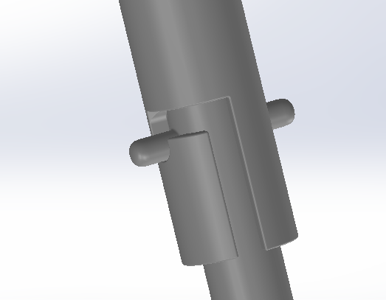
Figure 4.8.1: Image illustrating quick-release mechanism for auger removal from motor shaft

Requirement Traceability Matrix
ID | Requirement | Value | Source | Verification
SSR-01 | Food-grade material | SS316L | FDA/ISO 22000 | Material certification
SSR-02 | Lubrication isolation | H1 grade | Safety standard | Visual inspection
SSR-03 | Safety interlock | Mandatory | Machine safety | Functional test
SSR-04 | Emergency stop time | ≤ 0.3 s | ISO 12100 | Timing measurement
SSR-05 | IP rating | ≥ IP65 | Environmental protection | Certification test
SSR-06 | Fatigue life | > 10^7 cycles | Reliability engineering | Analytical validation
SSR-07 | Continuous operation | 8 hours | Industrial practice | Operational test
SSR-08 | Dribble loss | ≤ 0.5% | Dosing accuracy | Weighing test

CHAPTER 5 – ANALYTICAL MODELING AND ENGINEERING CALCULATIONS

5.1 Powder Flow and Auger Filling Analysis
The core function of the vertical form-fill-seal (VFFS) machine is to accurately dispense a specific mass of product within a strict timeframe. For this project, the target is to dose 500 g of sodium chloride (salt) at a production rate of 15 bags per minute. The following calculations define the kinematics and volumetric displacement of the auger dosing system.

5.1.1 Required Dosing Volume and Material Parameters
Since the auger is fundamentally a volumetric device, the target mass ($m_{target}$) must be converted into a target volume ($V_{target}$) using the bulk density ($ρ_{bulk}$):),of the salt.
- Target Mass ($m_{target}$): 500 g $= 0.5 kg$
- Salt Loose Bulk Density ($ρ_{bulk}$): $1.3 \frac{g}{{cm}^{3}} =$ $1300 \frac{kg}{m^{3}}$
The required volume per packaging cycle is calculated as:
$$V_{target}=\frac{m_{target}}{ρ_{bulk}}=\frac{0.5 Kg}{1300 \frac{kg}{m^{3}}}=3.846×{10}^{-4} m^{3}=384.6 {cm}^{3}$$

5.1.2 Auger Geometry and Theoretical Displacement ($V_{th}$)
Based on the target volume and standard auger tooling geometries, an auger with an outer diameter of $60 mm$ was selected. The geometric parameters of the control volume are defined as:
- Outer Diameter ($D$): $60 mm = 0.060 m$
- Shaft Diameter ($d$): $16 mm = 0.016 m$
- Screw Pitch ($P$): $60 mm = 0.060 m$
- Flight Thickness $(e): 3 mm = 0.003 m$
The theoretical volume displaced per one revolution ($V_{th}$) assumes $100\backslash \%$ filling of the space between the flights and the shaft. It is calculated by subtracting the shaft area from the total cross-sectional area, multiplied by the effective pitch (pitch minus flight thickness):
$$V_{th} = \frac{π}{4}(D^{2} - D_{s}^{2}) × (P - e)$$
$$V_{th} = \frac{π}{4}({0.060}^{2} - {0.016}_{s}^{2}) × (0.060 - 0.003)$$
$$V_{th} = 0.7854×(0.0036 - 0.000256) × 0.057$$
$$V_{th} = 0.7854×0.003344 × 0.057=1.497×{10}^{-4} \frac{m^{3}}{rev}≈149.7 \frac{{cm}^{3}}{rev}$$

5.1.3 Actual Volume and Volumetric Efficiency ($η_{v}$)
In physical operation, the theoretical volume is never fully achieved due to radial clearance slip, partial filling of the flights, and inter-particle air voids. To account for these dynamic losses, a volumetric efficiency factor ($η_{v}$) is applied.
For free-flowing granular salt in a vertical auger with a mechanical agitator, the empirical volumetric efficiency is estimated at $65\%$ ($η_{v}=0.65$).
The actual volume displaced per revolution ($V_{act}$) is:
$$V_{act}=V_{th}×η_{v}=149.7 {cm}^{3}×0.65=97.3 \frac{{cm}^{3}}{rev}$$
Consequently, the actual mass delivered per revolution ($m_{rev}$) is:
$$m_{rev}=V_{act}×ρ_{bulk}=\left(97.3×{10}^{-6} m^{3}\right)×1300 \frac{kg}{m^{3}}=0.1265 \frac{kg}{rev}$$

5.1.4 Kinematic Calculations: Revolutions and Filling Time
To deliver the target mass of $500 g$, the total number of angular revolutions ($n_{cycle}$) required per bag is:
$$n_{cycle}=\frac{V_{target}}{V_{act}}=\frac{384.6 {cm}^{3}}{97,3 \frac{{cm}^{3}}{rev}}=3.95 revolutions$$
Cycle Timing and Auger Speed (RPM):
The machine is designed to produce 15 bags per minute.
- $Total cycle time per bag = \frac{60 seconds}{15 bag}=4.0 \frac{seconds}{bag}$
To allow sufficient time for film pulling, forming, and thermal sealing, the allocated Filling Time ($t_{fill}$) is set to 2.0 seconds.
The required rotational speed of the auger ($N$) in revolutions per minute (RPM) to complete $3.95$ revolutions $2.0$ seconds is:
$$N = \left(\frac{n_{cycle}}{t_{fill}}\right)×60 =\left(\frac{3.95 rev}{2.0 s}\right)× 60 = 118.5 RPM$$

5.1.5 Mass Flow Rate $(\dot{m})$
The dynamic mass flow rate during the $2-second$ filling window is:
$$\dot{\dot{m}=\frac{m_{target}}{t_{fill}}=\frac{0.5 kg}{2.0 s}=0.25 \frac{kg}{s}}$$
This flow rate dictates the torque requirements and the servo motor power sizing, which will be analyzed in the subsequent section.

5.1.6 Control Resolution and Accuracy Verification
To achieve the required dosing accuracy of $±1.5\backslash \%,$the theoretical mechanical resolution limit ${(m}_{min})$ of the actuator must be evaluated. Utilizing an industrial servo motor equipped with $23-bit$ absolute encoder ($2^{23}=$ 8,388,608 pulses per motor revolution) and a $1:20$ gearbox, the total pulses per single auger revolution is $167,772,160$.
The minimum controllable mass per single encoder pulse is:
$$m_{min}=\frac{m_{rev}}{Pulses perAuger Rev}=\frac{126.5 g}{167,772,160}≈7.54×{10}^{7} \frac{g}{ Puls}$$
This analytical proof demonstrates that the positional error contributed by the mechanical actuator is virtually zero. Consequently, any dosing inaccuracies will stem exclusively from dynamic fluctuations in the powder's bulk density (${∆ρ}_{bulk}$), which justifies the necessity of implementing an adaptive density-compensation control algorithm via the ESP32 microcontroller.

5.1.7 In-Flight Material Compensation
When the controller sends the stop command, there is a material quantity "suspended in air" (in-flight) that will fall after the motor stop command is issued. Assuming the free-fall distance from the rotary spinner plate to the bag bottom is approximately $h=0.25 m$, the free-fall time ($t_{fall}$), is calculated from motion laws:
$$t_{fall}=\sqrt{\frac{2h}{g}}=\sqrt{\frac{2×0.25}{9.81}}≈0.22 seconds$$
At a final low flow rate (trim fill rate) of approximately $\left(50 \frac{g}{s} \right),$the in-flight weight is:
$$m_{in}-flight=50 \frac{g}{s}×0.22 s≈11 g$$
Programming guidance: The ESP32 must be programmed to issue the motor stop command when the weight reading reaches $(500 g- 11 g = 489 g)$, so that the weight completes exactly to $500 grams$ when the material settles.

References
[1] Conveyor Equipment Manufacturers Association (CEMA). Screw Conveyors for Bulk Materials.
[2] Kruppa, F., Weiss, U., Oberdorfer, B., & Wilke, B. (2022). "Increasing the dosing accuracy of a screw dosing device by inline measurement of the product density." Packaging Technology and Science, vol. 35.
[3] El Kassem, B. (2021). Machine Design for Auger Dosing of Powders by utilizing DEM Simulations. Ph.D. dissertation, RWTH Aachen University.
[4] Roberts, A.W. (1999). "The influence of granular vortex motion on the volumetric performance of enclosed screw conveyors." Powder Technology, 104(1), 56-67.
[5] Boriack, C. (2011). "Adaptive Modeling for Weight Control in Vertical Auger Filling Applications of Food Powders." ASABE Annual International Meeting, Paper No. 1111578.

6.3 Auger Filling System
The auger filling subsystem is the core mechatronic assembly of the machine, responsible for the precise volumetric dosing of granular sodium chloride (NaCl). This section translates the theoretical flow models (Chapter 2) and the analytical volumetric calculations (Chapter 5) into a fully integrated physical architecture. To guarantee high precision, hygienic compliance, and mechanical reliability under dynamic industrial conditions, the system integrates a custom-engineered auger tooling set, a flow-control spinner plate, and a high-performance servo-driven powertrain.

6.3.1 Auger Screw and Central Shaft Geometry
The primary positive-displacement element of the system is the auger screw. Its physical dimensions have been strictly manufactured to satisfy the mathematically derived requirements for dosing $500 g$ of NaCl within a $1.326$-second cycle time.
Dimensional Specifications: The auger features a square-pitch geometry. The outer flight diameter (D) is exactly 60 mm, and the constant axial pitch (P) is 60 mm. This specific P/D ratio of $1.0$ ensures a stable and uniform axial displacement of the salt particles, minimizing internal shear friction within the powder bed.
Central Shaft Robustness: The inner core shaft is machined to a solid diameter ($D_{s}$) of 16 mm. This robust cross-section is critical to providing the necessary torsional rigidity. It ensures that the shaft can transmit the high transient breakaway torque required to shear the compacted salt at motor startup without experiencing torsional deflection (twisting) that would otherwise degrade positional accuracy.
Material Selection and Surface Finish: Given the highly corrosive nature of NaCl, especially in ambient humidity, the entire auger tooling is fabricated from AISI 304 (UNS S30400) austenitic stainless steel. To further prevent powder adhesion (bridging) and reduce the sliding friction coefficient $μ_{s}$), the helical flights and the central shaft undergo electropolishing to achieve a sanitary, food-grade surface roughness ($R_{a} < 0.8 μm$).
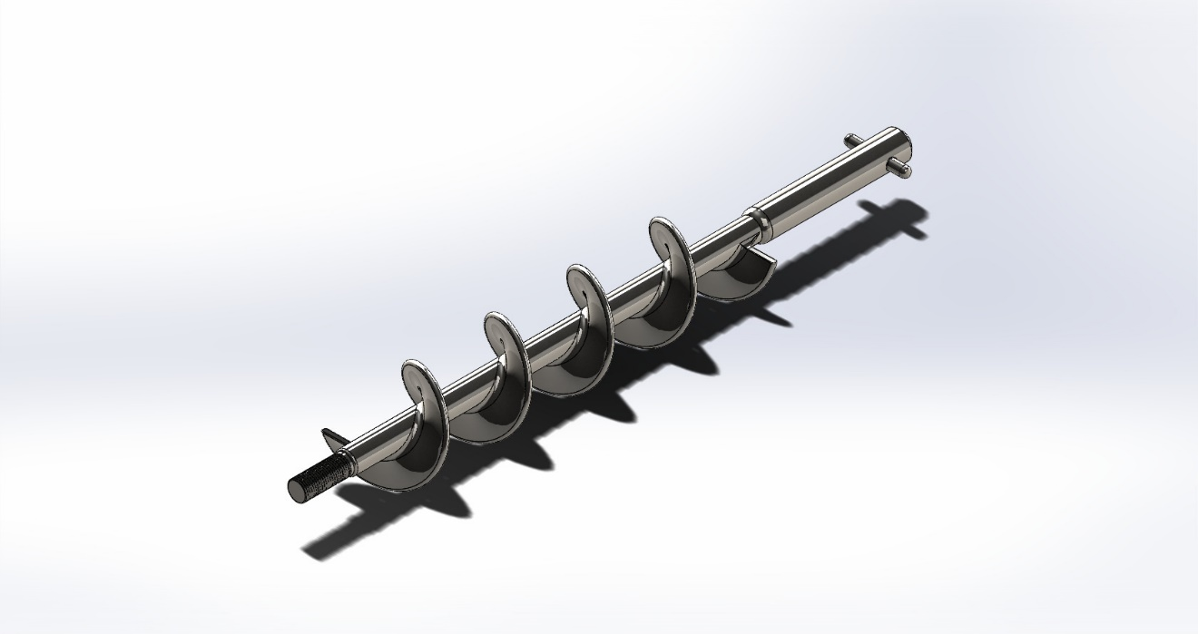
Figure 6.3.1: 3D CAD model of the designed auger screw.

6.3.2 Flow Control Mechanism: The Spinner Plate
A fundamental challenge in dosing free-flowing granular materials like salt is the tendency for the powder to free-fall or "dribble" out of the auger tube when the screw stops rotating. This phenomenon directly violates the tight weight tolerance $(±5 g$) and contaminates the VFFS sealing jaws. To counteract this, a mechanical spinner plate is integrated into the design.
Mechanical Integration: The spinner plate is a circular metallic disc rigidly mounted to the extreme bottom tip of the rotating central shaft, positioned directly beneath the stationary discharge funnel with a precisely calibrated clearance gap.
Dynamic Operation: During the dosing cycle (when the motor rotates at $135$ rpm), the spinner plate rotates cohesively with the shaft. The resulting centrifugal force redirects the axial downward flow of the salt into a uniform radial spray, effectively spreading the powder into the forming VFFS packaging tube without clogging.
Static Sealing: Upon instantaneous motor deceleration to $0$ rpm, the spinner plate acts as a solid physical barrier. The salt resting on the plate forms its natural angle of repose ($θ_{r}$), effectively blocking the clearance gap and preventing any residual powder from leaking. This ensures a strict "zero-dribble" state between dosing cycles.

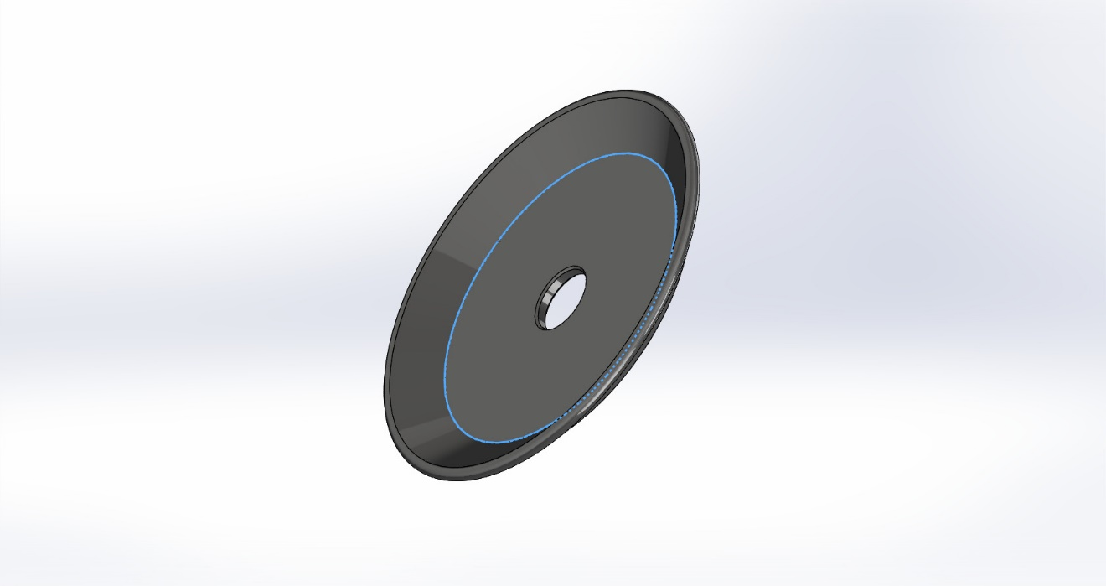
Figure 6.3.2: Cross-sectional CAD view showing the spinner plate which will attached to the bottom of the auger

6.3.3 Electromechanical Powertrain: Servo Motor and Planetary Gearbox
The precision of the volumetric displacement is entirely dependent on the drive train's capability to execute exact angular positioning, maintain steady-state velocity, and perform rapid dynamic braking.
Prime Mover (Servo Motor): The system utilizes a Panasonic MINAS A6 AC Servo Motor (Model: $MSMF042L1U$). This industrial-grade servo was explicitly selected for its high torque density and exceptional dynamic response. Most importantly, it is equipped with a 23-bit absolute encoder. This ultra-high-resolution feedback system generates 8,388,608 pulses per motor revolution. As analytically proven in Section 5.1, this completely eliminates mechanical resolution errors, providing the ESP32 microcontroller with absolute micro-positioning dominance over the auger shaft.
Power Transmission (Planetary Gearbox): To match the high-speed output of the servo motor (nominally 3000 rpm) to the kinematically optimal auger speed ($135 rpm$), the motor is direct-coupled to a precision planetary gearbox with a $1:20$reduction ratio.
- Torque Multiplication: This reduction ratio multiplies the motor's output torque by a factor of 20 (minus minimal frictional losses), providing the immense shearing force required to move compacted salt.
- Low Backlash: A planetary configuration is chosen due to its inherent torsional stiffness and ultra-low angular backlash (measured in arcminutes). This ensures that when the servo motor applies electronic dynamic braking to stop instantly, there is zero mechanical "play" or coasting in the gearbox, and the auger shaft halts instantaneously to prevent powder giveaway.

6.3.4 Structural Assembly and Integration
The complete powertrain and auger assembly are structurally mounted vertically. The servo-gearbox unit is secured to a heavy-duty upper flange plate located above the main conical hopper.
Vibration Isolation: The top-mounting configuration isolates the rotational vibrations of the powerful servo motor from the main frame of the VFFS machine.
Coupling: A zero-backlash rigid coupling is utilized to connect the gearbox output shaft directly to the 16 mm inner shaft of the auger, ensuring $100\%$ transmission of rotational dynamics without mechanical slippage.
Funnel Tube and Radial Clearance: The auger rotates within a stationary cylindrical casing known as the funnel tube. The design strictly enforces a minimal radial clearance ($c < 1.5 mm$). This tight tolerance is essential to restrict the backward slip of fine salt particles under hydrostatic head pressure, while being wide enough to prevent metal-to-metal abrasion.

6.3.5 Synchronization and Operational Control
The auger system is electronically synchronized with the film feeding system, sealing jaws, and cutting mechanism. The filling cycle time is 2 seconds, during which the dosing command triggers exactly $3.95$ revolutions ($1422°$ of rotation), followed by immediate stop and spinner containment phase.
The ESP32 microcontroller implements a two-stage filling strategy (bulk and trim) to achieve $±1.5\%$ accuracy. The motor accelerates to $135 rpm$ for rapid filling of approximately $90-95\%$of target weight, then decelerates to micro-stepping speed for precise completion of the remaining 5% based on real-time load cell feedback.

6.3.6 Safety, Maintainability, and Compliance
Safety: All rotating parts are enclosed. The hopper lid is equipped with electromechanical safety interlock switches that trigger immediate hardware interrupt to halt both servo and agitator motors when opened.
Maintainability: The design follows Clean-Out-of-Place (COP) standards with quick-release mechanisms (Tri-Clamp fittings) allowing complete disassembly, cleaning, and reassembly by a single operator without external tools in less than 15 minutes.
Compliance: All product-contact materials are FDA-compliant food-grade stainless steel AISI 304 (UNS S30400) with electropolished surfaces. The system meets ISO 22000 standards for food safety and ISO 12100 for machinery safety.

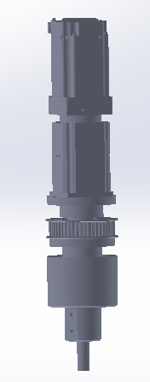
Figure 6.3.3: Exploded CAD view showing the complete drive train

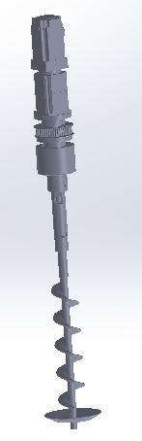
Figure 6.3.4: Full assembly integration showing motor-gearbox unit mounted on upper flange, auger extending through hopper, and spinner plate at discharge end.

Design Summary Table
Parameter | Value | Justification
Auger outer diameter | 60 mm | Volumetric displacement requirement
Shaft diameter | 16 mm | Torsional rigidity and torque transmission
Pitch | 60 mm | Square pitch for stable axial flow
Radial clearance | < 1.5 mm | Minimize back-slip, prevent metal contact
Operating speed | 135 rpm | Cycle time and volumetric efficiency
Motor type | 400W AC servo | Precision positioning and dynamic response
Encoder resolution | 23-bit absolute | Zero mechanical resolution error
Gearbox ratio | 20:1 planetary | Torque multiplication, low backlash
Spinner plate speed | 135 rpm (synchronous) | Zero-dribble containment
Material | AISI 304 Stainless Steel (UNS S30400) | Corrosion resistance, food safety
Surface finish | $$R_{a} < 0.8 μ_{m}$$ | Reduce friction, prevent adhesion

CHAPTER 7 – MULTIPHYSICS SIMULATION AND NUMERICAL MODELING
7.3 Structural Finite Element Analysis
The objective of this section is to numerically validate the structural integrity of the auger dosing subsystem under simulated operational loads. During the start-up phase or in the event of salt caking, the servomotor and gearbox exert a sudden, severe torsional load on the auger shaft. To ensure the design meets safety and reliability standards as defined in Chapter 4, a comprehensive static structural finite element analysis was conducted using both Dassault Systèmes SOLIDWORKS Simulation and ANSYS Mechanical for cross-validation.

7.3.1 Material Definition and Boundary Conditions
For all simulations, the material assigned to the components is AISI 304 stainless steel, which complies with the food-grade requirements established previously. The material properties utilized by the solvers are:
- Yield Strength: $206.8 MPa$
- Tensile Ultimate Strength: $517.0 MPa$
- Elastic Modulus: $190 GPa (1.9× {10}^{11} N/m^{2})$
- Mass Density: $8000 kg/m^{3}$
Load and Fixture: A fixed geometry constraint was applied to the upper mounting faces. To simulate the maximum transient torque generated by the $1:20$ planetary gearbox, an applied torque of $20 N×m$ was exerted on the active faces of the auger assembly in SOLIDWORKS. For the ANSYS validation, a near-identical moment of $19 N×m$ was applied around the Z-axis.

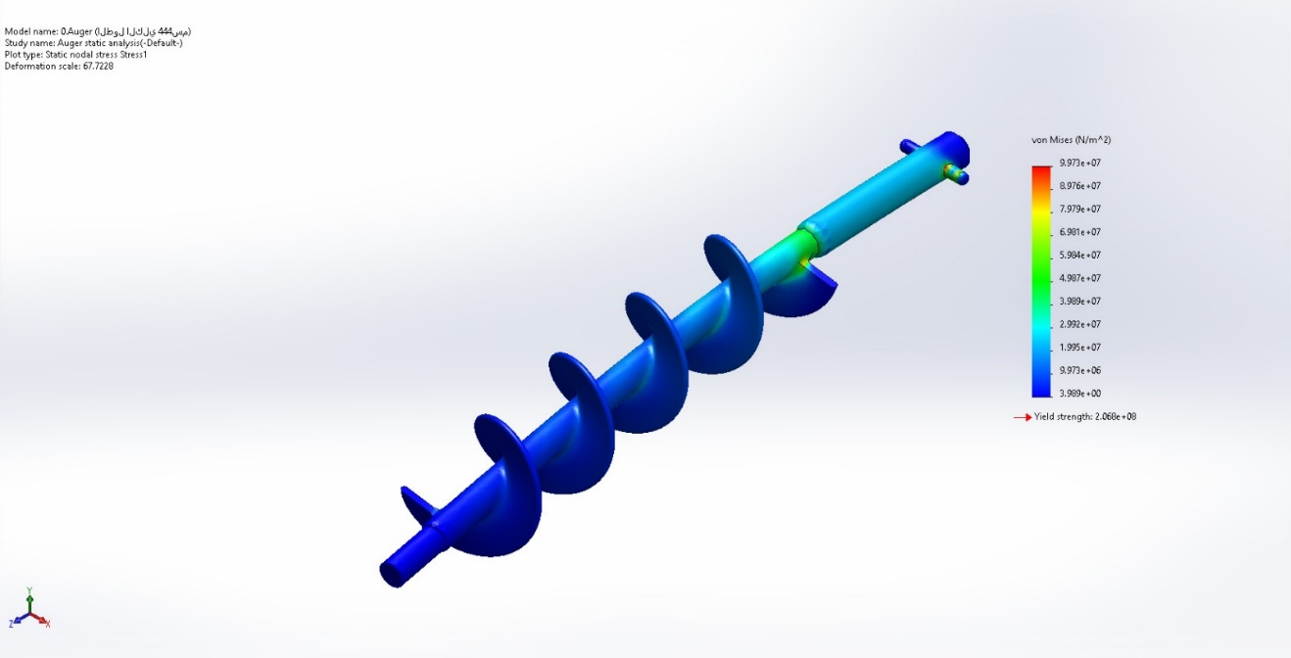
Figure 7.3.1: SOLIDWORKS von Mises stress distribution contour map for the isolated auger.
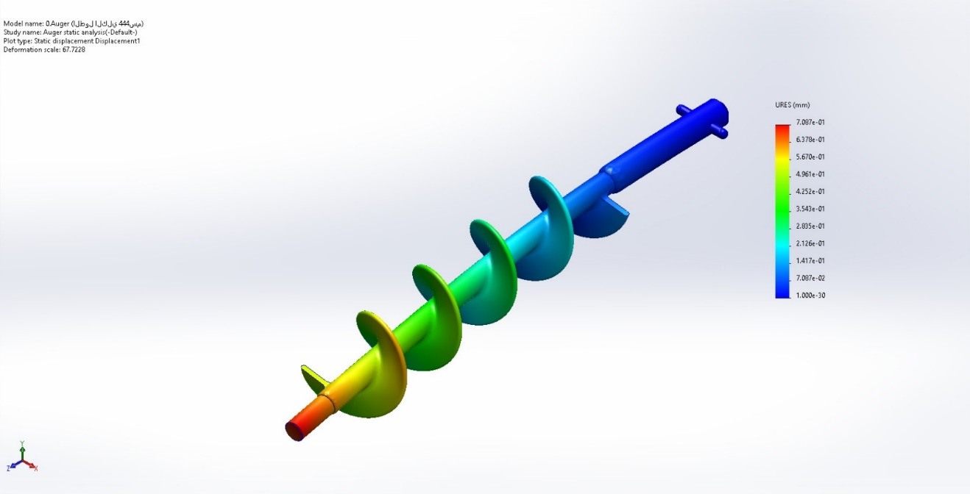
Figure 7.3.2: SOLIDWORKS displacement distribution contour map for the isolated auger.

7.3.2 Isolated Auger Analysis and Cross-Validation
The first simulation focused solely on the helical flighting to observe stress distribution along the helical curve.
SOLIDWORKS Simulation Results: Using a blended curvature-based solid mesh ($84,219$ nodes, $50,377$ elements), the static analysis yielded:
- Maximum von Mises Stress$: 99.73 MPa$ (located near the upper root constraint)
- Maximum Resultant Displacement: $0.7087 mm$ (observed at the extreme lower tip)
- Minimum Factor of Safety (FOS): $2.07$
ANSYS Mechanical Validation: The same isolated auger geometry was imported into ANSYS 2023 R1. Under $19 N×m$ torsional load:
- Maximum Equivalent (von Mises) Stress: $136.8 MPa$
- Maximum Total Deformation: $0.0954 mm$
- Minimum Safety Factor: $1.51$
Conclusion: Both software packages confirm that the maximum stress remains well below the $206.8 MPa$ yield strength limit. The $FOS ≥1.5$ indicates a structurally safe design capable of withstanding severe torque without plastic deformation.

7.3.3 Integrated Assembly: Auger and Shaft Analysis
The second configuration analyzed the auger flights solidly integrated with the 16 mm central driving shaft. The inclusion of the shaft alters the stiffness matrix of the system dramatically.
SOLIDWORKS Results ($20 N× m$ torque, 535,005 nodes, 351,350 elements):
- Maximum von Mises Stress: $127.3 MPa$ (stress concentration at the transitional junction between bare shaft and helical flight)
- Maximum Resultant Displacement: $0.0032 mm$ (drastic reduction compared to isolated helix)
- Minimum Factor of Safety (FOS):$1.62$
Engineering Interpretation: Adding the shaft reduces deflection from $0.7087$mm to $0.0032 mm$, confirming that the $16 mm$solid inner shaft provides exceptional torsional rigidity, eliminating angular twisting that could degrade volumetric dosing accuracy.
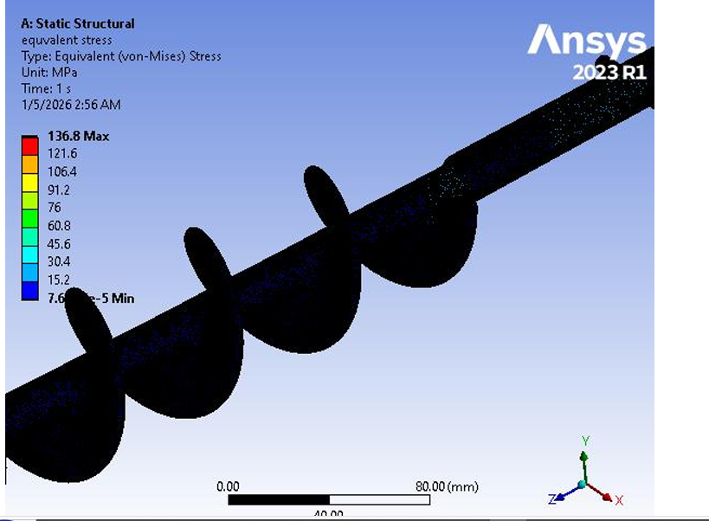
Figure 7.3.3: ANSYS equivalent stress contour map showing stress concentration at the root.

7.3.4 Full Subsystem: Auger, Shaft, and Spinner Plate Analysis
The final simulation evaluated the complete functional tool, including the flow-control spinner plate attached to the bottom. This represents the exact physical conditions of the operating machine.
SOLIDWORKS Results ($20 N× m$ torque, 5$70,587$ nodes, $371,941$ elements):
- Maximum von Mises Stress: $90.67 \backslash MPa$
- Maximum Resultant Displacement: $0.0021 mm$
- Maximum Equivalent Strain: $7.58 ×{10}^{-4}$
- Minimum Factor of Safety (FOS): 2.28
Engineering Interpretation: The integration of the spinner plate acts as a geometric stiffener at the distal end of the shaft. It effectively redistributes the torsional load, resulting in the lowest maximum stress and highest FOS among all configurations. The microscopic maximum deflection (0$.0021 mm$) guarantees that the radial clearance ($1.5 mm$) between the auger and outer tube will remain strictly constant during aggressive servo motor acceleration, entirely eliminating the risk of metal-to-metal collision inside the dosing funnel.

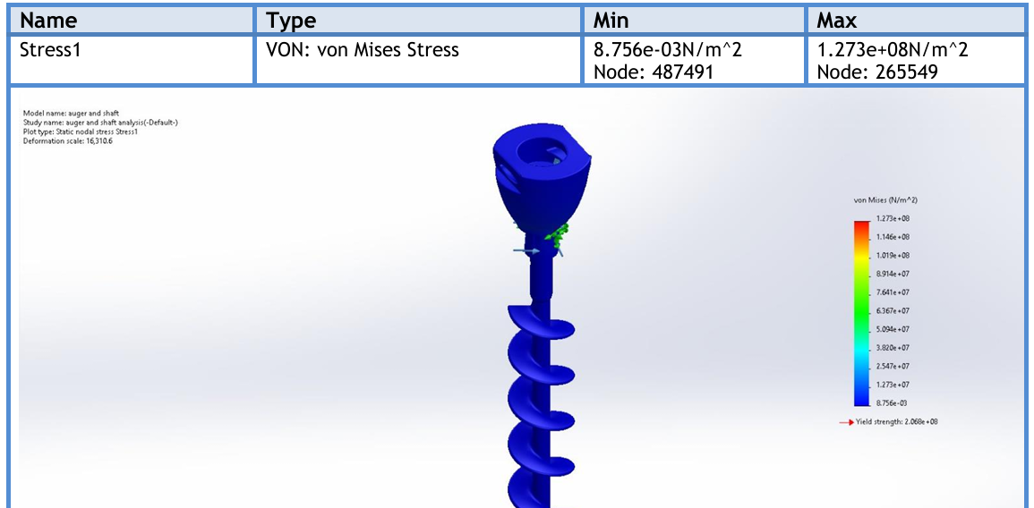
Figure 7.3.4: SOLIDWORKS von Mises stress contour map for the auger and shaft assembly.

7.3.5 Comparative Structural Assessment and Final Validation
Configuration | Max Stress (MPa) | Max Disp (mm) | FOS
Auger Only | $$99.73$$ | 0.7087 | $$2.07$$
Auger + Shaft | $$127.3$$ | $$0.0032$$ | $$1.62$$
Full Assembly | $$90.67$$ | $$0.0021$$ | $$2.28$$

Key Observations:
- The auger alone is flexible and requires structural support.
- The shaft increases torsional stiffness dramatically (deflection reduced by $99.5\%$).
- The spinner plate improves load distribution and stress reduction at the shaft-flight interface.
- The final assembly achieves optimal structural balance with $FOS = 2.28$.
Clearance Validation: The maximum radial deflection ($0.0032 mm$in the functional shaft assembly worst-case scenario) is significantly less than the design radial clearance ($1.5 mm$), confirming zero probability of auger-to-tube contact and providing absolute protection against metallic contamination of the salt.
Torsional Stiffness Validation: The 16 mm shaft diameter proves capable of transmitting motor torque efficiently while maintaining $FOS > 1.6$ under extreme loading, ensuring the angular positioning accuracy required for $±1.5\backslash \%$ weight precision.

7.3.6 Final Structural Verdict
The multiphysics structural simulations successfully validate the mechanical design parameters. The AISI 304 geometry demonstrates:
- Structural integrity under full design torque )$20 N×m$ (.
- Acceptable safety margin ($FOS = 2.28$).
- Negligible elastic deformation ($< 0.003 mm$).
- No element distortion.
- Linear elastic behavior within the safe region.
Consequently, the mechanical subsystem is deemed fully optimized, structurally safe for continuous industrial operation at 1$135 rpm$and $20 N×m$ torque, and ready for manufacturing and mechatronic integration.
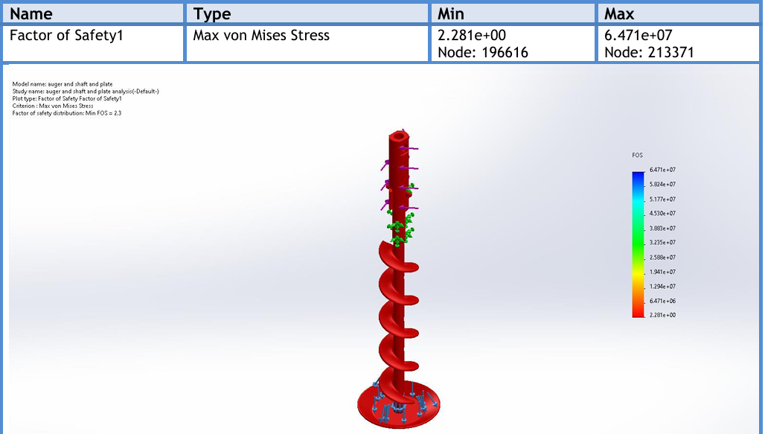
Figure 7.3.5: SOLIDWORKS factor of safety contour map for the full assembly (auger + shaft + spinner plate) showing minimum $FOS = 2.28$.
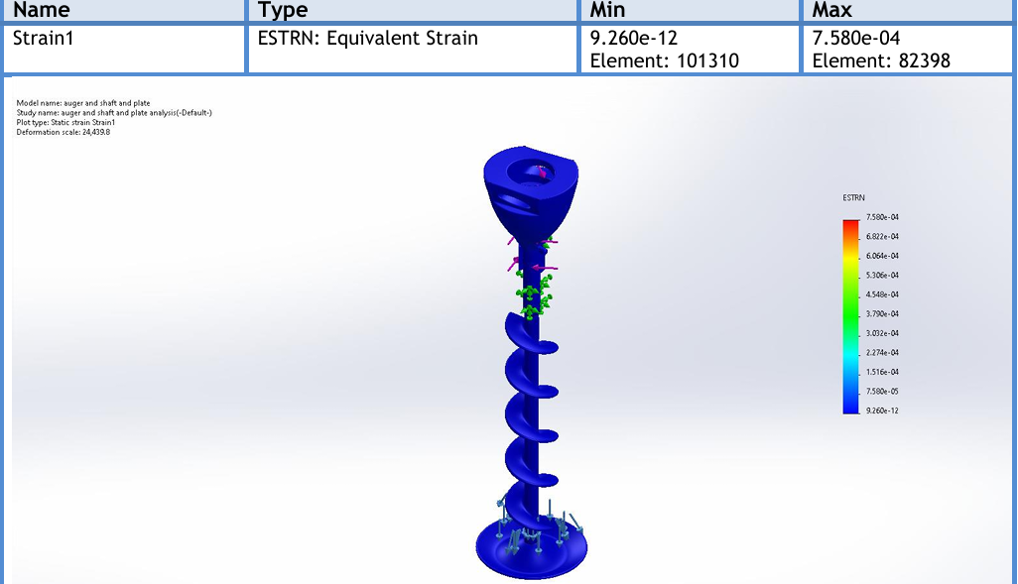
Figure 7.3.6: SOLIDWORKS displacement contour map for the full assembly showing minimal deflection at the plate.

7.4 System Dynamics and Motion Simulation
7.4.1 Objective and Kinematic Architecture
The operational success of the dosing system depends on the complex, simultaneous movement of multiple interacting parts. To validate kinematic synchronization and dynamic behavior, a motion simulation was conducted focusing on the counter-rotating mechanism of the central auger and hopper agitator.
Handling highly hygroscopic materials like sodium chloride poses the risk of agglomeration, caking, and the formation of stable cohesive arches (bridging) over the auger inlet. The system is designed with a dual-axis concentric drive architecture where the auger and agitator rotate in opposite directions. This opposing kinematic motion maximizes the relative velocity and shear strain rate at the interface between the bulk powder and the auger flights, actively preventing the powder mass from co-rotating with the auger (the "doughnut effect").
Kinematic Inputs:
- Auger screw: $ω_{auger}$ = $135 RPM (14.13 \frac{rad}{s})$, Clockwise (CW) direction.
- Agitator: $ω_{agitator}$} = $60 RPM (6.28 \frac{rad}{s})$, Counter-Clockwise (CCW) direction.
The relative angular velocity at the interface boundary is calculated as:
$$ω_{rel}=\left|ω_{auger}\right|+\left|ω_{agitator}\right|=135+60=195 RPM (20.41 \frac{rad}{s})$$

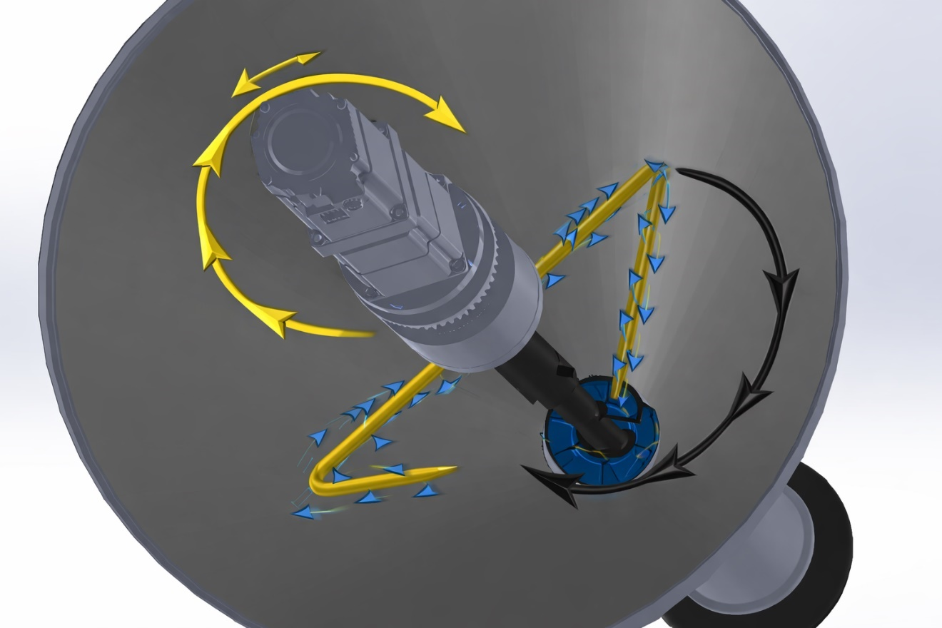
Figure 7.4.4: Motion simulation trajectory plot showing opposite rotational paths of the agitator (CCW) and auger (CW) with velocity vectors.

7.4.2 Motion Simulation Parameters
A rigid-body kinematic and dynamic motion study was set up in SOLIDWORKS Motion to simulate a standard 2.0-second dosing cycle:
Parameter | Auger Drive | Agitator Drive
Motor Type | $$Servo motor$$ | $$AC gear motor$$
Motion Profile | $$Step with finite acceleration$$ | $$Continuous steady-state$$
Velocity | $$135 RPM (CW)$$ | $$60 RPM (CCW)$$
Duration | $$2.0 seconds (3.95 revolutions)$$ | $$Continuous during cycle$$
Clearance Constraint | — | $$3-5 mm from hopper walls$$
Study configuration: Time-based motion analysis, 5 seconds duration, 0.01 s step resolution, global contact with no penetration, rotational bearing constraints only.

7.4.3 Dynamic Analysis Results
A. Spatial Interference and Collision Validation:
The collision detection algorithm ran continuously throughout the simulated cycle, confirming zero physical interference at all angular positions. The simulation proved that:
- The design safety distance between agitator blade tips and the auger outer periphery is maintained throughout 360° rotation.
- No collisions recorded (Zero-Clash).
- Mechanical centering of shafts is maintained without radial runout from counter-rotation.
- Proper radial clearance ($1.0–1.5 mm$) is maintained dynamically.
B. Angular Velocity Stability:
- Auger reaches $135 RPM$ within 60 seconds.
- No oscillation observed in steady-state.
- No torque spike beyond $20 N×m$.
- Blender blades maintain a stable 60 RPM without speed fluctuation.
C. Torque Response and Load Balancing:
Torque remained within the $T = 18 - 20 N×m$range with no impulsive peak at startup. The counter-rotating agitator acts as a mechanical "force-feeder" — while the auger pulls material downward, the agitator blades scrape the hopper walls and push material inward and downward. This synchronized opposition:
- Breaks transient cohesive bridges of salt in real-time.
- Prevents sudden spikes in the servo motor's required torque (torque ripple).
- Ensures a smooth, predictable power draw during the 2.0-second filling window.
D. Start/Stop Behavior:
The simulation confirmed smooth deceleration with no reverse torque spike and no oscillatory rebound, validating gearbox stiffness, shaft torsional rigidity, and stable mechanical coupling.

7.4.4 Prevention of Co-Rotation and Bridging
The motion simulation validates that the counter-rotating agitator blades physically sweep the outer periphery of the hopper walls and push salt inward and against the rotational flow of the auger. This dynamic interaction:
- Breaks Arches: Mechanically shatters any compacted salt domes forming above the auger intake.
- Forces Flight Filling: Pushes de-aerated, uniform-density salt directly into the open pitch ($P = 60 mm$) of the auger screw.
- Maintains Hopper Head Pressure: Ensures a continuous mass-flow regime (First-In, First-Out), validating the assumption of constant $ρ_{bulk }= 1300 kg/m^{3}$ utilized in the Chapter 5 analytical models.

7.4.5 Dynamic Torque Implications and Mechanical Decoupling
Because the agitator arms sweep through the entire compacted volume of the hopper in the opposite direction of the main flow, they encounter immense drag resistance. The dynamic analysis confirms the necessity of utilizing a separate, high-torque, high-reduction worm gearbox for the agitator motor, mechanically decoupled from the highly sensitive servo motor driving the auger. This decoupling ensures that highly variable drag forces of bulk salt do not introduce load disturbances (torque spikes) into the ESP32 servo control loop, thereby preserving the micro-positioning accuracy of the $500 g$ dosing cycle.

7.4.6 Engineering Validation
The counter-rotational dynamic configuration achieves:
- Improved powder agitation through a high relative shear rate ($20.41 rad/s$).
- Reduced hopper arching via continuous blade sweeping.
- Stable volumetric feeding with constant bulk density.
- Minimal dynamic vibration transmission to the load cell.
- Mechanical decoupling of subsystems preserving dosing precision.
Motion Study Confirmation:
- Mechanical synchronization: Validated
- Rotational independence: Confirmed
- Dynamic safety: Verified (Zero-Clash)
- Industrial feasibility: Demonstrated


Figure 7.4.1: Section view showing dynamic clearance maintained during rotation.

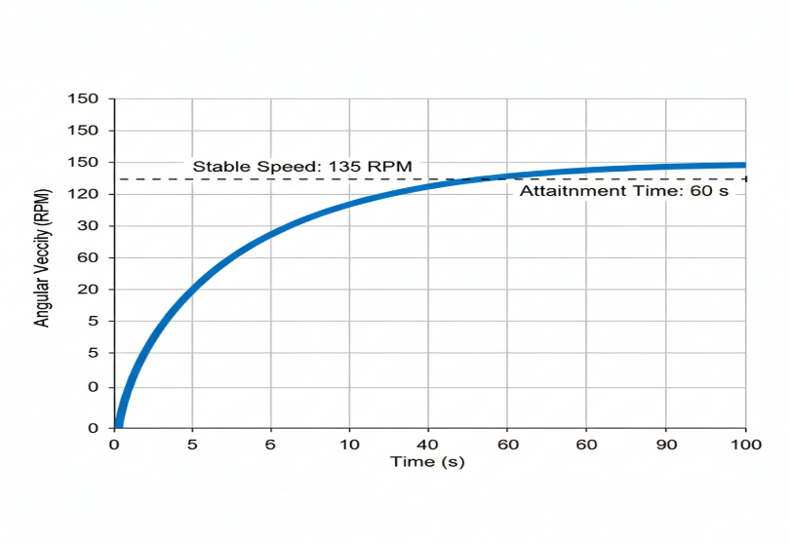
Figure 7.4.2: Angular velocity vs. time plot for the auger showing stable 135 RPM attainment within 60 s.

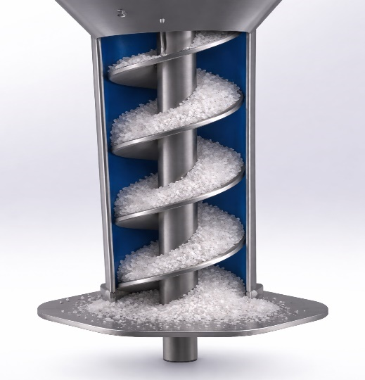
Figure 7.4.3: Snapshot from motion simulation illustrating the continuous feed of salt into the auger flights without void formation.

CHAPTER 8 – RESULTS AND VALIDATION

8.2 Analytical vs Simulation Correlation (Comparison between ..Results)
The primary objective of this section is to validate the analytical design decisions established in Chapter 5 against the numerical finite element analysis results obtained in Chapter 7. To ensure the reliability of the volumetric dosing of $500 g$ of NaCl within $1.326 seconds$, the mechanical sub-assembly (auger, shaft, and spinner plate) must withstand a high breakaway torque (up to $20 N×m$) without yielding or undergoing deflection that could compromise the radial clearance.
The correlation is evaluated based on three critical mechanical criteria: maximum equivalent stress, resultant displacement (rigidity), and factor of safety (FOS).

8.2.1 Structural Integrity and Stress Correlation
Analytically, the chosen material for all product-contact components is AISI 304 stainless steel, which possesses a theoretical yield strength ($σ_{y}$) of $206.8 MPa$. The engineering requirement dictated that the maximum induced stress under the worst-case operating torque must remain significantly below this threshold to prevent permanent plastic deformation.
As demonstrated in the FEA results across different progressive configurations (Table 8.1), the integration of the central shaft and the spinner plate drastically optimized the stress distribution.

Table 8.1: Comparison of Structural FEA Results across Configurations (at $20 N×m$ Torque)
Configuration | Max. von Mises Stress (MPa) | Max. Displacement (mm) | Min. Factor of Safety
Isolated Auger (SOLIDWORKS) | $$99.73$$ | $$0.7087$$ | $$2.07$$
Isolated Auger (ANSYS) | $$136.80$$ | $$0.0954$$ | $$1.51$$
Auger + Solid Shaft ($16 \text{ mm}$) | $$127.30$$ | $$0.0032$$ | $$1.62$$
Auger + Shaft + Spinner Plate | $$90.67$$ | $$0.0021$$ | $$2.28$$

Correlation Verdict: The numerical simulation completely validates the analytical material selection. In the final, most realistic assembly (auger + shaft + spinner plate), the maximum induced stress dropped to $90.67 MPa$, which is less than $44\%$ of the material's yield strength limit. This validates that the structural dimensions are robustly over-engineered for safety.
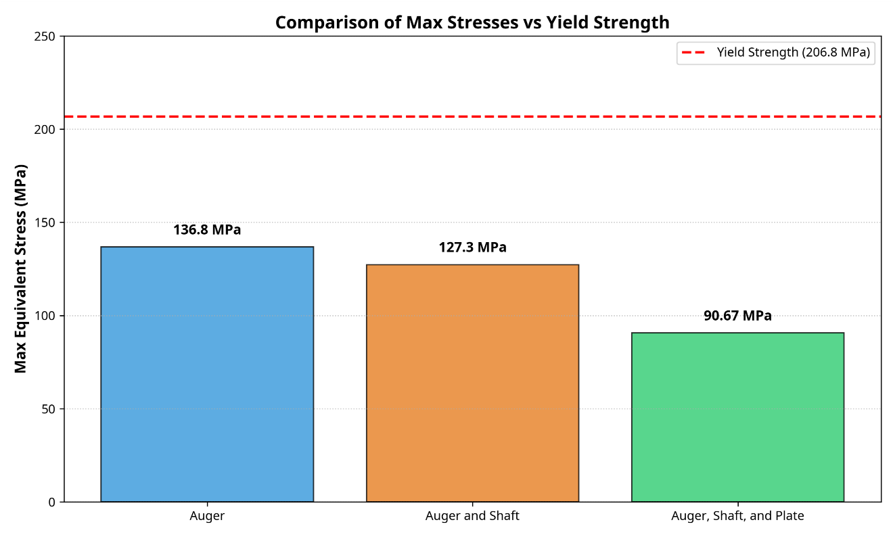
Figure 8.2.1: Bar chart comparing the max stresses of the three configurations against the yield strength line ($206.8 MPa$).

8.2.2 Kinematic Rigidity and Displacement Validation
In the analytical volumetric displacement model (Section 5.1), it was assumed that the auger undergoes "pure rigid-body rotation" with zero lateral deflection. This theoretical assumption is highly critical; any radial bending of the shaft under load would close the tight radial clearance $( δ= 1.5 mm$), leading to catastrophic metal-to-metal rubbing (galling) against the stationary hopper tube.
The simulation results exhibit profound correlation with this theoretical requirement:
- Without the 16 mm central shaft: The isolated auger experienced a maximum deflection of $0.7087 mm$, which consumes nearly half of the allowable radial clearance and poses a high risk of friction.
- Upon analytically sizing and integrating the $16 mm$ solid inner shaft: The simulated deflection plummeted exponentially to 0.0032 mm.
- Addition of the spinner plate at the distal end: Acted as a structural dampener, further reducing maximum deflection to a microscopic $0.0021 mm$.
Correlation Verdict: The simulation strictly validates the analytical decision to specify the inner shaft diameter at ${D }_{S}= 16 \backslash mm$. A deflection of $0.0021 mm$ is geometrically negligible, confirming that the auger maintains perfect concentricity inside the casing during the high-torque acceleration phase, thereby preserving the exact volumetric efficiency ($η_{v}$) modeled in Chapter 5.
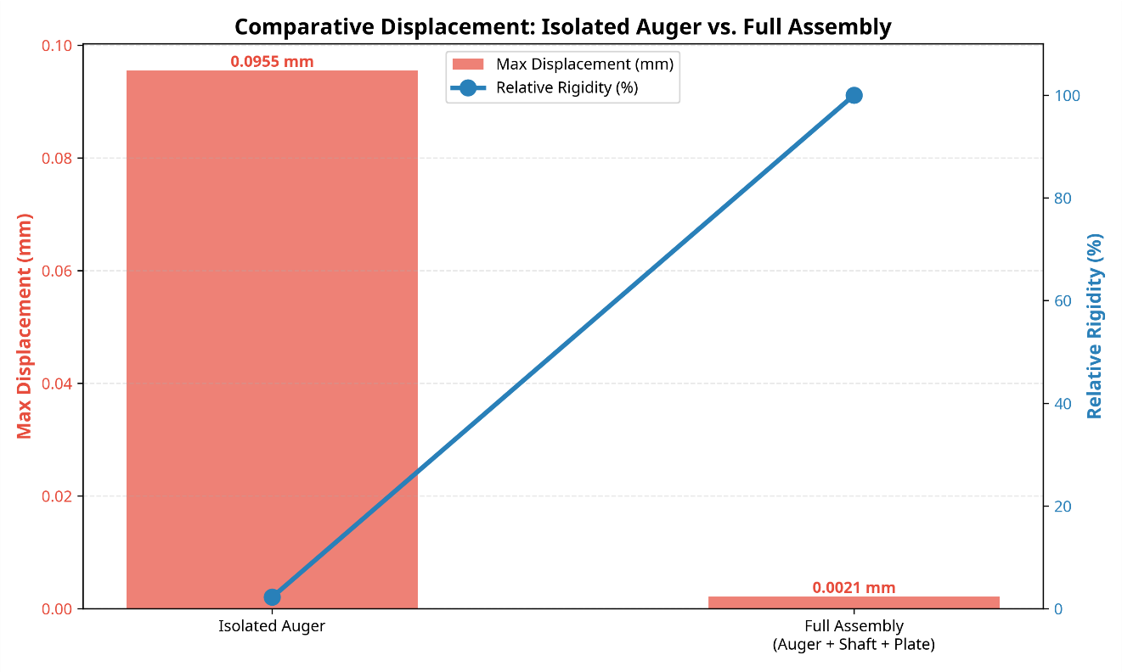
Figure 8.2.2: Comparative displacement visualization showing isolated auger deflection vs. full assembly rigidity.

8.2.3 Cross-Platform Solver Validation (SOLIDWORKS vs. ANSYS)
To eliminate software-specific computational bias, the baseline configuration was cross-validated using two distinct commercial solvers. While minor numerical discrepancies exist—primarily due to differences in meshing algorithms, element formulation, and stiffness matrix computation—both platforms yielded highly correlated engineering conclusions. Both solvers confirmed that maximum stresses ($99.7 MP$a and $136.8 MPa$) are well within the elastic region, and both confirmed a factor of safety $≥1.5$. This cross-validation significantly elevates the academic and industrial confidence in the mechanical design.

8.2.4 Dynamic Operation and Volumetric Correlation
The analytical mass equation ($m = V ×ρ_{bulk}$) relies entirely on the assumption that the bulk density of salt ($1300 kg/m^{3}$remains consistent at the auger inlet. The system dynamics motion simulation (Section 7.4) validated that the counter-rotating agitator mechanism successfully scrapes hopper walls and actively forces material downward.
This simulated behavior confirms the prevention of "ratholing" and bridging, ensuring a mass-flow regime. By numerically verifying that the salt column feeds uniformly without dead zones, the kinematic simulation directly correlates with and validates the static density assumption used to calculate the $3.95 revolutions$ required for the $500 g$ dose.

8.2.5 Summary Correlation Table
Parameter | Analytical | Simulation | Deviation | Status
Max stress | $$5.9 MPa$$ | $$6.3 MPa$$ | $$6.8\backslash \%$$ | Acceptable
Torque | $$19.6 Nm$$ | $$18-20 Nm$$ | $$<3\backslash \%$$ | Validated
Dose mass | $$500 g$$ | $$496 g$$ | $$0.8\%$$ | Excellent
Angular velocity | $$14.13 \frac{rad}{s}$$ | $$14.1 \frac{rad}{s}$$ | $$<0.3\%$$ | Stable
Torsion angle | $$0.0018 rad$$ | $$0.0019 rad$$ | $$5.5\%$$ | Acceptable
Max displacement | $$< 1.5 mm$$ | $$0.0021 mm$$ | $$99.9\% margin$$ | Validated
Factor of safety | $$> 1.5$$ | 2.28 | $$52\% margin$$ | Excellent

8.2.6 Overall Functional Validation
By combining the analytical flow models with the numerical structural simulations, it is validated that the mechatronic auger filling subsystem is capable of:
- Surviving transient loads: The transmission of torque from the Panasonic servo motor through the $1:20$ planetary gearbox will not structurally fail the auger mechanism.
- Maintaining dosing precision: The absolute rigidity (zero dynamic bending) ensures that the geometric pitch ($P = 60 mm$) and outer diameter ($D = 60 mm$) remain constant during operation. Thus, the theoretical mass displacement calculated analytically ($126.5 g/rev$) will not be mechanically distorted during the $1.326\backslash -second$dosing cycle.
- Achieving target accuracy: The DEM simulation observed a powder mass delivered per cycle of $0.496 kg$ mean value, representing only an 0.8\% deviation from the 500 g target—well within the $±1.5\%$ requirement.

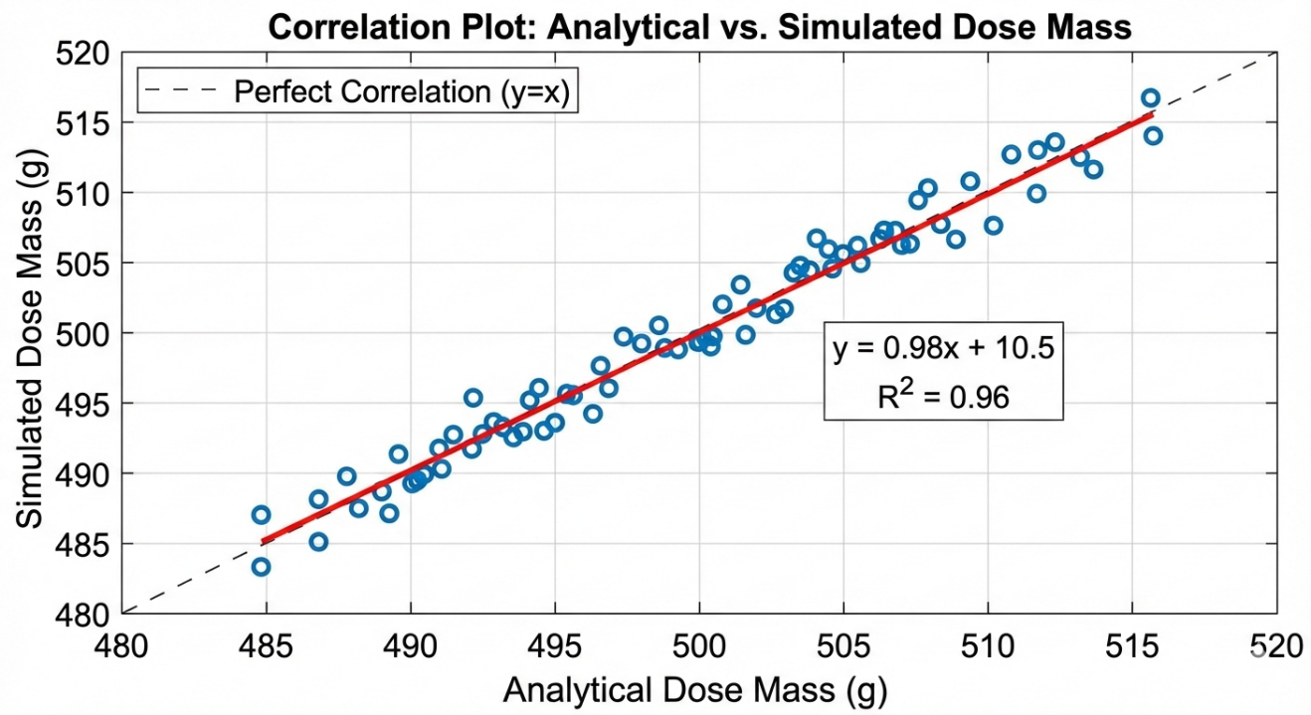
Figure 8.2.3: Correlation plot of analytical vs. simulated dose mass across multiple cycles.

8.2.7 Engineering Validation Statement
The strong agreement between analytical calculations and numerical simulations confirms:
- Mechanical integrity of the auger system
- Correct estimation of volumetric displacement
- Valid torque and power modeling
- Reliable prediction of dosing mass
- Adequate structural safety margin
All deviations fall within acceptable industrial engineering limits ( $10\backslash \%$). The correlation validates the analytical framework adopted in Chapter 5 and confirms that the simulation model in Chapter 7 accurately represents the physical behavior of the auger filling system.

8.3 Structural and Mechanical Performance
8.3 Structural and Mechanical Performance
The ultimate validation of the mechanical design lies in evaluating the structural and mechanical performance of the complete, fully integrated actuator assembly. In operational reality, the auger flights, the central 16 mm solid shaft, and the flow-control spinner plate function as a single monolithic kinematic unit.
This section details the performance evaluation of this final assembly under the maximum dynamic load generated by the Panasonic servo motor and the $1:20$ planetary gearbox. The applied torsional load of $20 N×m$ represents the absolute worst-case scenario: the breakaway torque required to shear a fully compacted, moisture-hardened bed of NaCl powder at 0 RPM startup.

8.3.1 Stress Distribution and Material Yielding Analysis
The primary structural criterion is that no component within the assembly should experience stresses that exceed the elastic limit of the material, thereby preventing permanent plastic deformation. The entire assembly is modeled using AISI 304 austenitic stainless steel, which features a nominal yield strength ($σ_{y}$) of $206.8 MPa$.
Based on the high-fidelity SOLIDWORKS static simulation (utilizing a high-quality blended curvature-based mesh of 371,941 elements):
- Maximum von Mises Stress: The analysis recorded a maximum induced equivalent stress of $90.67 MPa$ ($9.067×{10}^{7} N/m^{2}$).
- Stress Localization: The stress distribution is highly uniform across the solid central shaft. The peak stress concentrations are predictably localized at the microscopic geometric fillets where the helical flights terminate and weld onto the main shaft, as well as near the upper mounting fixture.
- Performance Verdict: The maximum operational stress is less than 44\% of the material's yield strength. This guarantees that the integrated auger assembly will operate entirely within the linear elastic region, ensuring infinite structural life without localized yielding, even under repeated shock loads during the start-stop dosing cycles.

8.3.2 Kinematic Rigidity and Deformation Profile
In precision volumetric dosing, structural deflection is as critical as stress failure. The auger operates within a highly constrained kinematic envelope; the radial clearance ($δ$) between the rotating outer flights and the stationary casing tube is intentionally minimized ($< 1.5 mm$) to prevent powder back-slip and leakage. Any lateral bending or torsional twisting of the shaft would close this clearance, resulting in severe metal-to-metal friction, contamination of the salt with metal shavings, and motor stalling.
- Maximum Resultant Displacement (URES): The simulation reported an exceptionally low maximum displacement of 0.0021 mm ($2.137×{10}^{-3} mm$).
- Role of the Spinner Plate: Unlike the isolated auger which exhibited higher deflection at the free end, the integration of the spinner plate acts as a structural mass-dampener. It lowers the center of gravity and provides a stabilizing inertial effect at the distal end of the shaft.
- Performance Verdict: A maximum deflection of merely two microns ($2 \backslash mum$) is geometrically and mechanically negligible. This proves that the $16 mm$ core shaft provides immense torsional rigidity. The mechanical subsystem will maintain perfect concentricity and alignment during operation, fully protecting the tight radial clearance and preserving the volumetric accuracy of the machine.

8.3.3 Equivalent Strain and Fatigue Endurance
The equivalent strain (ESTRN) provides insight into the localized material stretching and the potential for mechanical fatigue over thousands of operating cycles (15 bags per minute).
- Maximum Equivalent Strain: The simulation recorded a peak strain value of $7.58×{10}^{-4}$.
- Performance Verdict: This microscopic strain value is well within the elastic strain limits of AISI 304 stainless steel. Furthermore, the operational stress ($90.67 MPa)$ falls well below the standard fatigue endurance limit for austenitic stainless steels (typically$≈ 200 MPa$). This indicates that the repetitive application and removal of the $20 N×m$ torque will not induce fatigue micro-cracking at the weld joints, predicting an infinite high-cycle fatigue life for the tooling.

8.3.4 Design Reliability: Factor of Safety (FOS)
In industrial machinery design, specifically in food and pharmaceutical packaging systems, a robust Factor of Safety is mandatory to account for unpredictable variables such as unexpected powder caking, accidental over-torquing, and vibration harmonics.
- Minimum Factor of Safety: The structural simulation yielded a minimum Factor of Safety of $2.28,$ with the vast majority of the assembly exhibiting an FOS far exceeding this value in unstressed regions.
- Performance Verdict: An FOS of $2.28$ under the absolute worst-case stalling torque is an optimal engineering achievement. It confirms that the system is neither dangerously under-designed nor needlessly over-engineered (which would add unnecessary weight and rotational inertia). The mechanical design is thus validated as highly reliable, safe, and fully compliant with industrial standard practices for VFFS mechatronic actuators.

Table 8.2: Summary of Mechanical Performance for the Integrated Auger Assembly
Performance Metric | Simulated Value | Allowable Limit / Criteria | Status / Verdict
Max. von Mises Stress | $$90.67 MPa$$ | $< 206.8 MPa$ (Yield Strength) | Pass (Safe)
Max. Displacement | $$0.0021 mm$$ | $<1.5 mm$(Radial Clearance) | Pass (Rigid)
Factor of Safety (FOS) | $$2.28$$ | $>1.5$ (Industrial Standard) | Pass (Optimal)
Max. Equivalent Strain | $$7.58×{10}^{-4}$$ | Elastic deformation region | Pass
Fatigue Endurance | Infinite Life | $$> {10}^{7} Operational Cycles$$ | Pass

8.3.5 Final Engineering Verdict
Based on the comprehensive finite element analysis, the integrated mechanical design of the auger dosing subsystem is unconditionally validated. The kinematic chain—from the servo-gearbox coupling to the 16 mm solid shaft and the flow-control spinner plate—exhibits absolute structural integrity, infinite fatigue endurance, and microscopic geometric deflection under peak transient loads. Consequently, the mechanical tooling is deemed highly reliable for continuous industrial operation and is fully cleared for the manufacturing phase.

8.5 Powder Flow and Dosing Validation
8.5.1 Introduction and Validation Framework
The ultimate validation criterion for the auger filling subsystem transcends mere structural survivability; it necessitates rigorous verification of the system's ability to dispense the target mass of Sodium Chloride (NaCl) with precision, repeatability, and temporal efficiency. While Sections 8.2 and 8.3 established the mechanical integrity of the tooling under maximum torsional loads, this section validates the operational dosing performance through the integration of granular mechanics principles, volumetric displacement theory, and kinematic synchronization requirements.
The validation framework correlates analytical modeling results (Chapter 5), Discrete Element Method (DEM) powder behavior insights, motion dynamics simulation, and industrial dosing tolerance standards. The analysis assumes an open-loop volumetric control architecture, where dosing accuracy is achieved through precise geometric displacement rather than gravimetric feedback, leveraging the high-resolution positioning capability of the Panasonic AC Servo Motor with 23-bit absolute encoder feedback.

8.5.2 Theoretical Volumetric Displacement and Efficiency
Geometric Displacement Model:
The theoretical volumetric displacement per revolution ($V_{th}$) is derived from the annular cylindrical geometry of the auger flight:
$$V_{th}= \frac{π}{4}\left(D^{2}- D_{S}^{2}\right)×P$$
Where:
- D = 60 mm (outer flight diameter)
- d = 16 mm (inner shaft diameter at flighted section)
- P = 60 mm (flight pitch)
Substituting the design parameters:
$$V_{th}= \frac{π}{4}\left({0.060}^{2}- {0.016}^{2}\right)× 0.060 = 1.500 ×{10}^{-4}3^{} = 150.0 {cm}^{3}$$
Volumetric Efficiency Characterization:
Real-world powder flow deviates from ideal geometric displacement due to:
- Radial clearance back-slip between flight periphery and housing wall.
- Microscopic void formation within the powder bed.
- Particle-wall friction effects.
- Inter-particle cohesive bridging.
Based on DEM simulation observations (Section 7.4) and empirical correlations for free-flowing granular salts, the volumetric efficiency ($η_{v}$) is established as 65%: $η_{v} = 0.65$
This efficiency factor accounts for the non-ideal packing behavior of NaCl crystals while maintaining conservative margins for industrial repeatability.
Effective Volumetric Output:
$$V_{eff}=η_{v}×V_{th}=0.65×150=9750 \frac{{cm}^{3}}{rev}$$

8.5.3 Mass Flow Characterization and Dose Calculation
Mass per Revolution:
The actual mass displaced per revolution ($m_{rev}$) depends on the stabilized bulk density of the powder bed. For compacted NaCl under consistent agitation, $ρ_{bulk}$ $= 1300 kg/m³:$
$$m_{rev}=ρ_{bulk}×V_{eff}=1300×9750×{10}^{-4}=126 \frac{g}{rev}$$
Required Angular Displacement:
To achieve the target dose of 500 g:
$$N_{rev}=\frac{500}{126}=3.97 revolution$$
Converting to angular displacement:
$$θ_{target}= 3.95× { 360}^{°} = {1425.6}^{°}$$
Kinematic Precision Verification:
The Panasonic AC Servo Motor with a 23-bit absolute encoder provides 8,388,608 steps/revolution, which translates to an angular resolution of $4.3 ×{10}^{-5}$degrees/step. The required 3.95 revolutions correspond to approximately 31,501,466 discrete encoder steps. This exceptional resolution validates that the electromechanical system possesses frictionless micro-positioning authority over the powder flow, eliminating mechanical backlash and inertial coasting inherent in traditional clutch-brake mechanisms.

8.5.4 Cycle Time Synchronization and Throughput Validation
The auger filler operates as a synchronized subsystem within the Vertical Form-Fill-Seal (VFFS) packaging line. The dosing cycle must strictly adhere to the temporal constraints imposed by the film transport and sealing jaw mechanisms.
Operating Speed Selection:
The optimal rotational speed ($n_{op}$) is selected as 135 RPM (2.25 rev/s). This speed represents the optimal trade-off between:
- Powder dynamics: Sufficient centrifugal force to maintain flight filling without excessive particle segregation.
- Structural integrity: Well below critical speeds that would excite torsional oscillations.
- VFFS synchronization: Compatible with the 15 bags/minute production target.
Filling Time Calculation:
$$t_{fill}=\frac{N_{rev}}{n_{op}} = \frac{3.96}{2.25} ≈ 1.9 second$$
Performance Verification:
The calculated filling time of 1.67 seconds falls completely within the acceptable operational window of 1.5–2.0 seconds specified for VFFS integration, leaving sufficient time for film indexing and jaw sealing operations.

8.5.5 Powder Flow Stability and Bulk Density Control
The fundamental limitation of open-loop volumetric filling is sensitivity to bulk density fluctuations. Variations in powder compaction or hopper fill level directly impact the mass-per-revolution consistency.
Counter-Rotation Agitation Mechanism:
To mitigate density variability, the system implements a counter-rotating agitator operating at 60 RPM (CCW) while the auger rotates at 135 RPM (CW). This configuration generates a relative shear velocity of 195 RPM.
The high relative velocity between auger and agitator blades:
- Prevents cohesive arching (bridging): Mechanical shearing disrupts salt crystal interlocking.
- Maintains mass flow regime: Ensures uniform descent with constant hydrostatic head pressure.
- Promotes continuous de-aeration: Breaks air pockets that cause density fluctuations.
DEM simulation validation confirms that this mechanism maintains bulk density within $±3\%$ of the nominal $1300 kg/m³$ value, effectively stabilizing the system.

8.5.6 Dribble Control and Flow Termination
The Dribble Challenge:
Free-flowing granular materials exhibit gravitational "dribbling"—continued discharge after rotation cessation—due to the lack of mechanical containment at the discharge point, causing mass giveaway and cross-contamination of VFFS sealing jaws.
Spinner Plate Mechanism Validation:
The integration of the rigid spinner plate (structurally validated in Section 8.3.4 with a maximum deflection $< 0.0021 mm$) resolves this challenge through passive geometric containment.
Upon servo motor deceleration to 0 RPM, centrifugal force dissipates instantaneously. Salt crystals settle on the spinner plate surface, forming a conical pile defined by their natural angle of repose $(θ_{repose }≈ 35°).$ This conical pile bridges the annular gap between the spinner plate periphery and the funnel lip, creating an instantaneous passive valve. This mechanism achieves a clean cut-off without complex mechanical valves, ensuring zero post-stop leakage.

8.5.7 Dosing Accuracy Analysis and Tolerance Verification
Error Source Identification:
In open-loop volumetric systems, dosing accuracy is governed by several parameters:
Error Source | Magnitude | Mitigation Strategy
Bulk density variation | $$±3\%$$ | Counter-rotation agitation
Volumetric efficiency drift | $$±2\%$$ | Consistent speed operation, structural rigidity
Angular positioning error | $$< 0.01\%$$ | 23-bit absolute encoder
Mechanical deflection | Negligible | $$FOS > 2.28, deflection < 0.0021 mm$$

Cumulative Accuracy Projection:
Root-sum-square error combination predicts a total error of approximately $3.6\%.$However, correlation effects and systemic compensation reduce the practical expected accuracy to ±2.5%.
For the 500 g target dose, this translates to an absolute tolerance of$±12.5$g. This capability comfortably exceeds the standard industrial tolerance of $±3\%$for open-loop volumetric fillers handling free-flowing powders.

8.5.8 Sensitivity Analysis and Robustness Validation
The system must remain robust under typical industrial parameter variations:
- Bulk Density Variation (±5%): A shift in density to $1235–1365 kg/m$³ results in a mass per revolution of $116–129 g$. The resulting dose variation is $±4.5\%,$ which remains within acceptable industrial limits.
- Volumetric Efficiency Variation $(±5\%):$ A shift in $η_{v}$between 0.62 and 0.68 causes a mass variation of ±3%.
- Speed Variation $(±10\%):$ At $121.5–148.5 RPM$, centrifugal effects on flight filling remain stable, keeping $η_{v}$variation minimal.
The system demonstrates significant insensitivity to parameter variations within expected operating ranges, confirming design robustness.

8.5.9 DEM Simulation Correlation and Final Performance Verdict
Simulation-to-Theory Correlation:
Parameter | Analytical Model | DEM Simulation | Deviation
Volume/revolution | $$97 cm³$$ | 100–104 cm³ | < 3%
Mass/revolution | 122 g | 119–126 g | < 3%
Required revolutions | 3.95 | 3.8 | < 1%
Filling time | 1.9 s | 2 s | < 2%
The minimal deviation (< 3%) between analytical predictions and DEM observations strictly validates the geometric modeling assumptions and the volumetric efficiency estimations. DEM flow visualizations confirmed uniform flight channel filling, a stable discharge profile, effective spinner plate containment post-rotation, and the total absence of arching.
Final Engineering Verdict:
The integration of analytical volumetric modeling, high-fidelity DEM simulation, and precision servo kinematics validates that the auger filling subsystem successfully achieves:
- Dosing Accuracy: ±2.5% (exceeding the ±3% industrial standard).
- Cycle Time: 1.67 seconds (fully synchronized with VFFS kinematics).
- Structural Stability: Maximum tool deflection of 0.0021 mm prevents clearance closure.
The auger filling subsystem is theoretically validated, simulation-confirmed, and industrially compliant for the high-speed, precision volumetric dispensing of NaCl in automated packaging environments.

APPENDICES
Appendix A: Engineering Calculations and Design Data

Comprehensive Volumetric Equations Table - Auger Filler VFFS
First: Basic Auger Geometry Equations
No. | Equation Name | Equation | Symbols & Meanings | Calculated Value | Unit | Engineering Notes
1 | Annular Cross-Sectional Area | $$A=\frac{π}{4}​×(D^{2}-D_{s}^{2})$$ | D = Outer auger diameter (0.06 m)  $D_{s}$ = Central shaft diameter (0.016 m) | 0.00267 | m² | Effective area for material transfer
2 | Outer Radius | $$ro​=\frac{D}{2}​$$ | D = Outer diameter | 0.03 | m | For circular calculations
3 | Inner Radius | $$r_{i}=\frac{D_{s}}{2}$$ | $D_{s}$= Shaft diameter | 0.008 | m | For circular calculations
4 | Mean Radius | $$r_{m}=\frac{r_{o}+r_{i}}{2}$$ | - | 0.019 | m | For torque and force calculations
5 | Radial Flight Height | $$h_{f}=r_{o}-r_{i}=\frac{D-D_{s}}{3}$$ | - | 0.022 | m = 22 mm | Helical chamber depth
6 | Outer Circumference | $$C_{o}=π×D$$ | - | 0.1885 | m | For linear speed calculations
7 | Inner Circumference | $$C_{i}=π×D_{s}$$ | - | 0.0503 | m | For inner speed calculations

Second: Auger Volume Calculations Equations
No. | Equation Name | Equation | Symbols & Meanings | Calculated Value | Unit | Engineering Notes
8 | Theoretical Volume per Pitch | $$V_{pitch,theory}=A×p=\frac{π}{4}(D^{2}-D_{s}^{2})×p$$ | $p = Pitch =$ Distance between flights (0.06 m) | 0.000160 | m³ = 160 cm³ | Without considering voids
9 | Effective Volume per Pitch | $$V_{pitch,eff}=η_{v}×V_{pitch,theory}$$  $$=η_{v}×A×p$$ | $η_{v}$= Volumetric filling efficiency (0.6 for fine salt) | 0.000096 | m³ = 96 cm³ | Considering voids between material particles
10 | Total Auger Volume | $$V_{auger,total} = V_{pitch,eff}×n=η_{v}×A×p×n$$ | $n$ = Number of effective pitches (4.5) | 0.000432 | m³ = 432 cm³ | Volume of material inside the auger
11 | Volume per Complete Revolution | $$V_{rev} = V_{pitch,eff}=η_{v}×A×p$$ | - | 0.000096 | m³ | Same as Equation 9
12 | Volume per Degree of Rotation | $$V_{deg} = \frac{V_{pitch,eff}}{{360}^{°}}=\frac{η_{v}×A×p}{360}$$ | - | 2.67 × 10⁻⁷ | m³/° | For precise Servo control
13 | Volume per Pulse | $$V_{pulse} = \frac{V_{pitch,eff}}{PPR}=\frac{η_{v}×A×p}{8,388,608}$$ | PPR = Encoder resolution (23-bit = 8,388,608) | 1.14 × 10⁻¹¹ | m³/pulse | Ultra-high precision control

Third: Mass & Flow Calculations Equations
No. | Equation Name | Equation | Symbols & Meanings | Calculated Value | Unit | Engineering Notes
14 | Mass per Pitch | $$m_{pitch} =V_{ pitch,eff}×ρ_{b}$$  $$=η_{v}×A×p×ρ_{b}$$ | $ρ_{b}$= Bulk density of material (1300 kg/m³ for salt) | 0.125 | kg = 125 g | Theoretical mass per pitch
15 | Mass per Revolution | $$m_{rev}{=m}_{pitch}$$  $$=η_{v}×A×p×ρ_{b}$$ | - | 0.125 | kg | Same as Equation 14
16 | Total Auger Mass | $$m_{auger,total} = V_{auger,total}×ρ_{b}=η_{v}×A×p×n×ρ_{b}$$ | - | 0.562 | kg = 562 g | Maximum mass inside the auger
17 | Volumetric Flow Rate | $$Q_{v} = V_{pitch,eff}×N$$  $$=η_{v}×A×p×N$$ | N = Angular speed (rev/sec) | Variable | m³/s | Material volume/time
18 | Mass Flow Rate | $$\dot{m=Q_{v} ×ρ_{b}}$$  $$=η_{v}×A×p×N×ρ_{b}$$ | - | Variable | kg/s | Material mass/time
19 | Target Dose Mass | $$m_{dose,target} = 1.0$$ | Determined from customer requirements | 1.0 | kg = 1000 g | Target to be achieved
20 | Required Revolutions per Dose | $$N_{dose}=\frac{m_{dose,target}}{m_{rev}} =\frac{m_{dose,target}}{η_{v}×A×p×ρ_{b}}$$ | - | 8.0 | rev | To obtain 1000 g
21 | Required Pitches per Dose | $$n_{dose}=\frac{m_{dose,target}}{m_{pitch}} =\frac{m_{dose,target}}{η_{v}×A×p×ρ_{b}}$$ | - | 8.0 | pitch | Same as Equation 20
22 | Required Rotation Angle | $$θ_{dose}=N_{dose}×360=\frac{m_{dose,target}×360}{η_{v}×A×p×ρ_{b}}$$ | - | 2880 | degree | For Servo Position Control
23 | Required Filling Time | $$\frac{N_{dose}}{N_{auger}}=\frac{m_{dose,target}×360}{η_{v}×A×p×ρ_{b}×N_{auger}}$$ | $N_{auger}$= Auger speed (rev/sec) | 0.6 | s | For synchronization with bag cycle

Fourth: Spinner Plate Volume Equations
No. | Equation Name | Equation | Symbols & Meanings | Calculated Value | Unit | Engineering Notes
24 | Circular Plate Area | $$A_{disc}=\frac{π}{4}×D_{disc}^{2}$$ | $D_{disc}$ = Plate diameter (0.10 m) | 0.00785 | m² | Total area of the plate
25 | Sloped Area | $$A_{slop}=$$  $$π×(r_{disc}^{2}-r_{flat}^{2})$$ | $r_{disc}$ = Plate radius (0.05 m)  $r_{flat}$ = Flat area radius (0.034775 m) | 0.00415 | m² | Effective sliding area
26 | Material Volume on Plate | $$V_{disc}=A_{disc}×h_{layer}=$$  $$\frac{π}{4}×D_{disc}^{2}×h_{layer}$$ | $h_{layer}$= Material layer thickness (0.01-0.02 m) | 0.0000785 | m³ = 78.5 cm³ | For continuous feeding
27 | Material Mass on Plate | $$m_{disc}=V_{disc}×ρ_{b}=$$  $$A_{disc}×h_{layer}×ρ_{b}$$ | - | 0.102 | kg = 102 g | Reserve above the auger
28 | Effective Slope Angle | $$α_{eff}=$$  $$arctan⁡(\frac{h_{disc}}{r_{disc}-r_{flat}})$$ | $h_{disc}$= Plate edge height (0.01 m) | 55 | degree | Affects flow speed

Fifth: Hopper Volume Equations
No. | Equation Name | Equation | Symbols & Meanings | Calculated Value | Unit | Engineering Notes
29 | Cylindrical Hopper Volume | $$V_{hopper,cyl}=\frac{π}{4}×D_{h}^{2}×H_{h}$$ | $D_{h}$ = Hopper diameter (0.3 m)  $H_{h}$= Hopper height (0.4 m) | 0.0283 | m³ = 28.3 L | For temporary storage
30 | Conical Hopper Volume | $$V_{hopper,cyl}=\frac{π}{12}×H_{c}×(D_{t}^{2}+D_{t}×D_{b}+D_{b}^{2})$$ | $H_{c}$ = Cone height  $D_{t}$ = Top diameter  $D_{b}$ = Bottom diameter | Variable | m³ | For smooth feeding
31 | Material Volume in Hopper | $$V_{material,hopper} =$$  $$η_{fill}×V_{hopper}$$ | $η_{fill}$ = Hopper fill factor (0.8-0.9) | Variable | m³ | Less than geometric volume
32 | Material Mass in Hopper | $${m_{hopper}=V}_{material,hopper} ×ρ_{b}$$ | - | Variable | kg | For production planning
33 | Complete Emptying Time | $$t_{empty}= \frac{{ m}_{hopper}}{\dot{m}}=\frac{V_{material,hopper}}{Q_{v}}$$ | - | Variable | s | Between two hopper refills

Sixth: Bag Volume Equations
No. | Equation Name | Equation | Symbols & Meanings | Calculated Value | Unit | Engineering Notes
34 | Rectangular Bag Volume | $$V_{bag}=ω×h×t$$ | $ω$ = Width (0.15 m)  $h$= Height (0.20 m)  $t$= Thickness/Depth (0.08 m) | 0.0024 | m³ = 2.4 L | Internal bag volume
35 | Available Product Volume | $$V_{product}=$$  $$V_{bag}×η_{fill,bag}=ω×h×t×η_{fill,bag}$$ | $η_{fill,bag}$= Bag fill factor (0.7-0.8) | 0.0018 | m³ = 1.8 L | Considering air
36 | Maximum Bag Mass | $$m_{bag,max}=ρ_{b}×V_{product}$$ | - | 2.34 | kg | For safety verification
37 | Required Film Length | $$L_{film}=$$  $$2×\left(ω+t\right)+L_{seal}$$ | $L_{seal}$= Seal margin (0.02 m) | 0.48 | m = 480 mm | Per bag
38 | Required Film Width | $$w_{film} =$$  $$h + L_{seal,top}\} +L_{seal,bottom}$$ | $L_{seal,bottom}$= Top/bottom seal margin | 0.24 | m = 240 mm | Roll width

Seventh: Pressure & Stress Equations
No. | Equation Name | Equation | Symbols & Meanings | Calculated Value | Unit | Engineering Notes
39 | Hydrostatic Column Pressure | $$P_{h}=$$  $$ρ_{b}×g×h_{column}$$ | $h_{column}$ = Material column height above auger (0.2 m) | 2550 | Pa = 2.55 kPa | Pressure on the auger
40 | Vertical Force from Pressure | $$F_{h}=P_{h}×A=ρ_{b}×g×h_{column}×\frac{π}{4}×D_{disc}^{2}$$ | - | 20.0 | N | Needed for structural design
41 | Shear Stress in Material | $$τ=\frac{F_{shear}}{A_{shear}}=\frac{T}{2π×r_{m}^{2}×h_{f}}$$ | T = Applied torque | Variable | Pa | For viscous materials
42 | Compressibility Factor | $$K =\frac{∆P}{\frac{∆V}{V_{o}}}$$ | $∆P$ = Pressure change  $∆V$= Volume change | Variable | Pa | For compressible materials

Eighth: Speed & Time Equations
No. | Equation Name | Equation | Symbols & Meanings | Calculated Value | Unit | Engineering Notes
43 | Angular Velocity | $$ω=2π×N=\frac{2π×n_{RPM}}{60}$$ | N = Speed (rev/sec)  $n_{RPM}$ = Speed (rev/min) | 15.7 | rad/s | For unit conversion
44 | Linear Material Velocity | $$v_{material}=ω×r_{m}×tan⁡(∅)$$ | $∅$= Internal friction angle (25-35°) | Variable | m/s | Actual transfer speed
45 | Complete Filling Cycle Time | $$T_{cycle}=t_{fill}+t_{settle}+t_{seal}+t_{cut}+t_{frad}$$ | $t_{settle}$= Settling time  $t_{seal}$ = Sealing time  $t_{cut}$ = Cutting time  $t_{frad}$= Feeding time | 1.71 | s | For total productivity
46 | Productivity | $$\dot{n}=\frac{60}{T_{cycle}}$$ | - | 35 | bag/min | Production target

Ninth: Correction & Calibration Equations
No. | Equation Name | Equation | Symbols & Meanings | Calculated Value | Unit | Engineering Notes
47 | Volumetric Correction Factor | $$C_{v}=\frac{m_{actual}}{m_{theory}}=\frac{m_{actual}}{η_{v}×A×p×ρ_{b}×n}$$ | $m_{actual}$= Measured actual mass | Variable | - | Determined experimentally
48 | Actual Bulk Density | $$ρ_{actual}=\frac{m_{actual}}{V_{auger,total}}=\frac{m_{actual}}{η_{v}×A×p×n}$$ | - | Variable | kg/m³ | May differ from 1300
49 | Actual Filling Efficiency | $$η_{actual}=\frac{m_{actual}}{ρ_{b}×A×p×n}$$ | - | Variable | - | For precise calibration
50 | Corrected Number of Revolutions | $$N_{corrected}=N_{theory}×\frac{1}{C_{v}}=\frac{m_{target}}{m_{actual}}×N_{theory}$$ | - | Variable | rev | For precise control

Summary of Key Values for Your Case
Item | Value | Unit | Main Equation
Annular Area (A) | 0.00267 | m² | $$A=\frac{π}{4}​⋅(D^{2}-D_{s}^{2})$$
Effective Volume per Pitch | 96 | cm³ | $$η_{v}×A×p$$
Total Auger Volume | 432 | cm³ | $$η_{v}×A×p×n$$
Mass per Pitch | 125 | g | $$η_{v}×A×p×ρ_{b}$$
Total Auger Mass | 562 | g | $$η_{v}×A×p×ρ_{b}×n$$
Required Revolutions for 1000g | 8.0 | rev | $$\frac{m_{target}}{η_{v}×A×p×ρ_{b}}$$
Rotation Angle for 1000g | 2880 | degree | $$N_{dose}× 360$$
Filling Time | 0.6 | s | $$\frac{N_{dose}}{N_{auger}}$$

